CUSTOMER SEGMENTATION
Num, Name = input("Reg. Number:"), input("Name:")
Reg. Number:20MIA1025
Name:NIKITHA AR
I. Introduction
II. Background - This project is about customer segmentation. Wherein, we divide the customers into segments based on their characteristics and apply a ‘personalized targeting’ technique to take the market to the customers effectively. The segments help us to optimize the significance of each customer to the business, hence modifying specific products and the market to the needs of the customer. Demographics, behaviour, benefit groups, social data of the customers and the value of the products are some of the ways which help segment customers effectively in the given data.
III . Motivation - The motivation of Personalized targeting involves specific product data and behavioural characteristics to determine which group/segment of people increases or decreases the product value in the market, which group ensures more profit in a given time period and applying special strategies to increase sales in the respective sector. The segments also help us to get proper feedback on what the customers need and cater to their needs. These segments can be formed with the help of techniques like Statistical Analysis, Outlier Analysis, Clustering and Apriori algorithms
IV. Statement- We have taken a groceries firm’s database wherein we are going to clean the data for anomalies, outliers and errors, pre-process it, reduce the dimensionality to get a detailed look of the sectors about to be grouped, creating segments from the behaviour, evaluate the clusters using visualization with certain criteria’s and pattern arrangement, profile the data and end with conclusions about each cluster we have. This entire process will give a solution to bring the products to the market by the needs of the customer, target the sales pitch on the required cluster and to cater to the needs of every cluster and their uses.
V. Challenges - The challenges faced by author includes cleaning the data before being used for analysis, extracting features from the processed data necessary for analysis and reducing the dimensionality of data down to four important features . Analysing the final results to draw appropriate conclusions.
Data –
Our dataset contains the following features :
AcceptedCmp1 - 1 if customer accepted the offer in the 1st campaign, 0 otherwise
AcceptedCmp2 - 1 if customer accepted the offer in the 2nd campaign, 0 otherwise
AcceptedCmp3 - 1 if customer accepted the offer in the 3rd campaign, 0 otherwise
AcceptedCmp4 - 1 if customer accepted the offer in the 4th campaign, 0 otherwise
AcceptedCmp5 - 1 if customer accepted the offer in the 5th campaign, 0 otherwise
Response (target) - 1 if customer accepted the offer in the last campaign, 0 otherwise
Complain - 1 if customer complained in the last 2 years
DtCustomer - date of customer’s enrolment with the company
Education - customer’s level of education
Marital - customer’s marital status
Kidhome - number of small children in customer’s household
Teenhome - number of teenagers in customer’s household
Income - customer’s yearly household income
MntFishProducts - amount spent on fish products in the last 2 years
MntMeatProducts - amount spent on meat products in the last 2 years
MntFruits - amount spent on fruits products in the last 2 years
MntSweetProducts - amount spent on sweet products in the last 2 years
MntWines - amount spent on wine products in the last 2 years
MntGoldProds - amount spent on gold products in the last 2 years
NumDealsPurchases - number of purchases made with discount
NumCatalogPurchases - number of purchases made using catalogue
NumStorePurchases - number of purchases made directly in stores
NumWebPurchases - number of purchases made through company’s web site
NumWebVisitsMonth - number of visits to company’s web site in the last month
Recency - number of days since the last purchase
We would be performing clustering on the basis of the spending, seniority and family size of customers. Whereas we would also be using apriori algorithm to predict common patterns of buying among customers from above data.
# Topics Covered: Data cleaning, visualisation of the required columns/items, feature engineering
# Clustering and KMeans, outlier analysis, SNS plots, Apriori algorithm to find patterns
# PCA, subplots, scatter plots and barplot visualization, Machine Learning
import matplotlib.pyplot as plt
import numpy as np
import pandas as pd
import seaborn as sns
import pandoc
---------------------------------------------------------------------------
ModuleNotFoundError Traceback (most recent call last)
<ipython-input-2-11ccc0dbfc49> in <module>
3 import pandas as pd
4 import seaborn as sns
----> 5 import pandoc
ModuleNotFoundError: No module named 'pandoc'
# https://www.kaggle.com/rodsaldanha/arketing-campaign
df=pd.read_csv("C:\\Users\\nikki\\Downloads\\marketing_campaign.csv", sep=";")
df.head(10)
ID Year_Birth Education Marital_Status Income Kidhome Teenhome \
0 5524 1957 Graduation Single 58138.0 0 0
1 2174 1954 Graduation Single 46344.0 1 1
2 4141 1965 Graduation Together 71613.0 0 0
3 6182 1984 Graduation Together 26646.0 1 0
4 5324 1981 PhD Married 58293.0 1 0
5 7446 1967 Master Together 62513.0 0 1
6 965 1971 Graduation Divorced 55635.0 0 1
7 6177 1985 PhD Married 33454.0 1 0
8 4855 1974 PhD Together 30351.0 1 0
9 5899 1950 PhD Together 5648.0 1 1
Dt_Customer Recency MntWines ... NumWebVisitsMonth AcceptedCmp3 \
0 2012-09-04 58 635 ... 7 0
1 2014-03-08 38 11 ... 5 0
2 2013-08-21 26 426 ... 4 0
3 2014-02-10 26 11 ... 6 0
4 2014-01-19 94 173 ... 5 0
5 2013-09-09 16 520 ... 6 0
6 2012-11-13 34 235 ... 6 0
7 2013-05-08 32 76 ... 8 0
8 2013-06-06 19 14 ... 9 0
9 2014-03-13 68 28 ... 20 1
AcceptedCmp4 AcceptedCmp5 AcceptedCmp1 AcceptedCmp2 Complain \
0 0 0 0 0 0
1 0 0 0 0 0
2 0 0 0 0 0
3 0 0 0 0 0
4 0 0 0 0 0
5 0 0 0 0 0
6 0 0 0 0 0
7 0 0 0 0 0
8 0 0 0 0 0
9 0 0 0 0 0
Z_CostContact Z_Revenue Response
0 3 11 1
1 3 11 0
2 3 11 0
3 3 11 0
4 3 11 0
5 3 11 0
6 3 11 0
7 3 11 0
8 3 11 1
9 3 11 0
[10 rows x 29 columns]
df.info()
<class 'pandas.core.frame.DataFrame'>
RangeIndex: 2240 entries, 0 to 2239
Data columns (total 29 columns):
# Column Non-Null Count Dtype
--- ------ -------------- -----
0 ID 2240 non-null int64
1 Year_Birth 2240 non-null int64
2 Education 2240 non-null object
3 Marital_Status 2240 non-null object
4 Income 2216 non-null float64
5 Kidhome 2240 non-null int64
6 Teenhome 2240 non-null int64
7 Dt_Customer 2240 non-null object
8 Recency 2240 non-null int64
9 MntWines 2240 non-null int64
10 MntFruits 2240 non-null int64
11 MntMeatProducts 2240 non-null int64
12 MntFishProducts 2240 non-null int64
13 MntSweetProducts 2240 non-null int64
14 MntGoldProds 2240 non-null int64
15 NumDealsPurchases 2240 non-null int64
16 NumWebPurchases 2240 non-null int64
17 NumCatalogPurchases 2240 non-null int64
18 NumStorePurchases 2240 non-null int64
19 NumWebVisitsMonth 2240 non-null int64
20 AcceptedCmp3 2240 non-null int64
21 AcceptedCmp4 2240 non-null int64
22 AcceptedCmp5 2240 non-null int64
23 AcceptedCmp1 2240 non-null int64
24 AcceptedCmp2 2240 non-null int64
25 Complain 2240 non-null int64
26 Z_CostContact 2240 non-null int64
27 Z_Revenue 2240 non-null int64
28 Response 2240 non-null int64
dtypes: float64(1), int64(25), object(3)
memory usage: 507.6+ KB
#object
#non null income 24 values
# datatype for date
df.nunique()
ID 2240
Year_Birth 59
Education 5
Marital_Status 8
Income 1974
Kidhome 3
Teenhome 3
Dt_Customer 663
Recency 100
MntWines 776
MntFruits 158
MntMeatProducts 558
MntFishProducts 182
MntSweetProducts 177
MntGoldProds 213
NumDealsPurchases 15
NumWebPurchases 15
NumCatalogPurchases 14
NumStorePurchases 14
NumWebVisitsMonth 16
AcceptedCmp3 2
AcceptedCmp4 2
AcceptedCmp5 2
AcceptedCmp1 2
AcceptedCmp2 2
Complain 2
Z_CostContact 1
Z_Revenue 1
Response 2
dtype: int64
# there are missing values in income (24 values)
#some categorical values are in form of objects . we will need to change them
#DT_customer should be date time value
#education can be made numerical for easier analysis
#martial status can be made numerical
#z_costcontact and z_revenue seem to have constant data so we can drop it
df["Income"].value_counts().sort_index().head()
1730.0 1
2447.0 1
3502.0 1
4023.0 1
4428.0 1
Name: Income, dtype: int64
# we notice that income doesnt have any 0 which is unusual generally
# also the rest of the variables are present except income for particular ids
# so we can safely replace null values with 0 indicating no income for the given data
df["Income"].fillna(0,inplace=True)
df.isna().any()
ID False
Year_Birth False
Education False
Marital_Status False
Income False
Kidhome False
Teenhome False
Dt_Customer False
Recency False
MntWines False
MntFruits False
MntMeatProducts False
MntFishProducts False
MntSweetProducts False
MntGoldProds False
NumDealsPurchases False
NumWebPurchases False
NumCatalogPurchases False
NumStorePurchases False
NumWebVisitsMonth False
AcceptedCmp3 False
AcceptedCmp4 False
AcceptedCmp5 False
AcceptedCmp1 False
AcceptedCmp2 False
Complain False
Z_CostContact False
Z_Revenue False
Response False
dtype: bool
# with missing value treated we can move further to explore our data
df["Dt_Customer"]=pd.to_datetime(df["Dt_Customer"])
print("The last customer recorded was on -",df["Dt_Customer"].max())
print("The first customer recorded was on -",df["Dt_Customer"].min())
The last customer recorded was on - 2014-06-29 00:00:00
The first customer recorded was on - 2012-07-30 00:00:00
# Before cleaning of the columns martial status and education for proper analysis
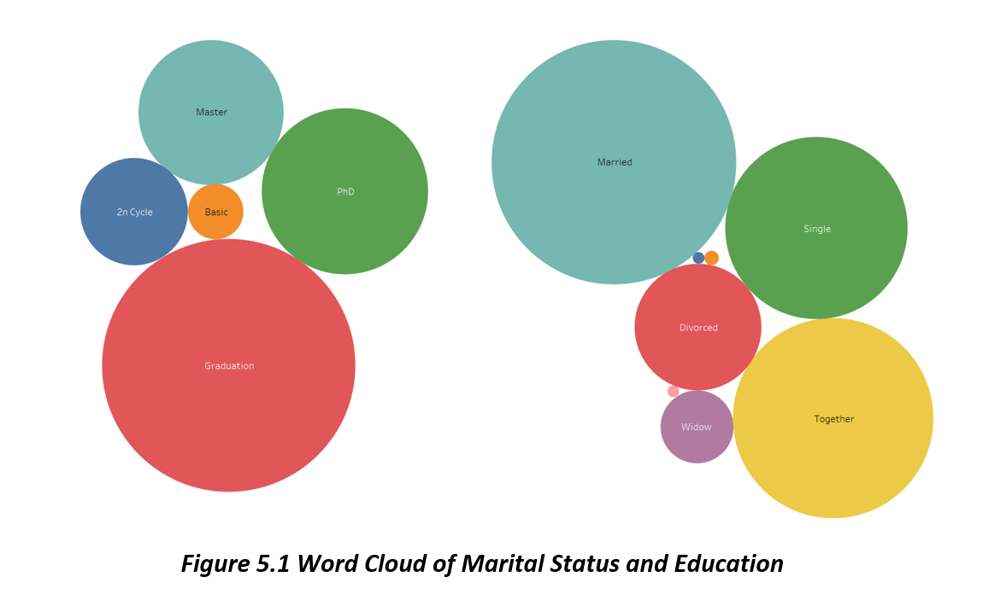

Word Cloud created using Tableau
df['Marital_Status'].value_counts()
Married 864
Together 580
Single 480
Divorced 232
Widow 77
Alone 3
Absurd 2
YOLO 2
Name: Marital_Status, dtype: int64
# we notice that there are lot of bad values in marital status . we will first need to clean them
# Cleaning involves creating a new column and grouping married and together values aas partner and the rest all as alone
marital_dict={"Married":"Partner", "Together":"Partner", "Absurd":"Alone", "Widow":"Alone", "YOLO":"Alone", "Divorced":"Alone", "Single":"Alone",}
df["Living_With"]=df["Marital_Status"].replace(marital_dict)
df['Living_With'].value_counts()
Partner 1444
Alone 796
Name: Living_With, dtype: int64
df["Marital_Status"]=df["Marital_Status"].replace({"Alone":"Single","Absurd":"Single","YOLO":"Single"})
df["Marital_Status"].value_counts()
Married 864
Together 580
Single 487
Divorced 232
Widow 77
Name: Marital_Status, dtype: int64
# A table showing how many values have been grouped to alone and partner from each of the Marital status column
pd.crosstab(df["Marital_Status"],df["Living_With"])
Living_With Alone Partner
Marital_Status
Divorced 232 0
Married 0 864
Single 487 0
Together 0 580
Widow 77 0
Our dataset contains more couples as compared to singles
# Education also has more number of values which we are convert into three itemsets by grouping
# As graduate, postgraduate and undergraduate
df["Education"].value_counts()
Graduation 1127
PhD 486
Master 370
2n Cycle 203
Basic 54
Name: Education, dtype: int64
#lets group these values by level to provide more clarity
df["Education"]=df["Education"].replace({"Basic":"Undergraduate","2n Cycle":"Undergraduate", "Graduation":"Graduate", "Master":"Postgraduate", "PhD":"Postgraduate"})
df["Education"].value_counts()
Graduate 1127
Postgraduate 856
Undergraduate 257
Name: Education, dtype: int64
Our dataset contains educated indivuals more. we can expect the income category to be on the higher side
df.info()
<class 'pandas.core.frame.DataFrame'>
RangeIndex: 2240 entries, 0 to 2239
Data columns (total 30 columns):
# Column Non-Null Count Dtype
--- ------ -------------- -----
0 ID 2240 non-null int64
1 Year_Birth 2240 non-null int64
2 Education 2240 non-null object
3 Marital_Status 2240 non-null object
4 Income 2240 non-null float64
5 Kidhome 2240 non-null int64
6 Teenhome 2240 non-null int64
7 Dt_Customer 2240 non-null datetime64[ns]
8 Recency 2240 non-null int64
9 MntWines 2240 non-null int64
10 MntFruits 2240 non-null int64
11 MntMeatProducts 2240 non-null int64
12 MntFishProducts 2240 non-null int64
13 MntSweetProducts 2240 non-null int64
14 MntGoldProds 2240 non-null int64
15 NumDealsPurchases 2240 non-null int64
16 NumWebPurchases 2240 non-null int64
17 NumCatalogPurchases 2240 non-null int64
18 NumStorePurchases 2240 non-null int64
19 NumWebVisitsMonth 2240 non-null int64
20 AcceptedCmp3 2240 non-null int64
21 AcceptedCmp4 2240 non-null int64
22 AcceptedCmp5 2240 non-null int64
23 AcceptedCmp1 2240 non-null int64
24 AcceptedCmp2 2240 non-null int64
25 Complain 2240 non-null int64
26 Z_CostContact 2240 non-null int64
27 Z_Revenue 2240 non-null int64
28 Response 2240 non-null int64
29 Living_With 2240 non-null object
dtypes: datetime64[ns](1), float64(1), int64(25), object(3)
memory usage: 525.1+ KB
df.nunique()
ID 2240
Year_Birth 59
Education 3
Marital_Status 5
Income 1975
Kidhome 3
Teenhome 3
Dt_Customer 663
Recency 100
MntWines 776
MntFruits 158
MntMeatProducts 558
MntFishProducts 182
MntSweetProducts 177
MntGoldProds 213
NumDealsPurchases 15
NumWebPurchases 15
NumCatalogPurchases 14
NumStorePurchases 14
NumWebVisitsMonth 16
AcceptedCmp3 2
AcceptedCmp4 2
AcceptedCmp5 2
AcceptedCmp1 2
AcceptedCmp2 2
Complain 2
Z_CostContact 1
Z_Revenue 1
Response 2
Living_With 2
dtype: int64
# here we conclude cleaning the data
# now we can move to see the basic distribution of data before we add features to our data
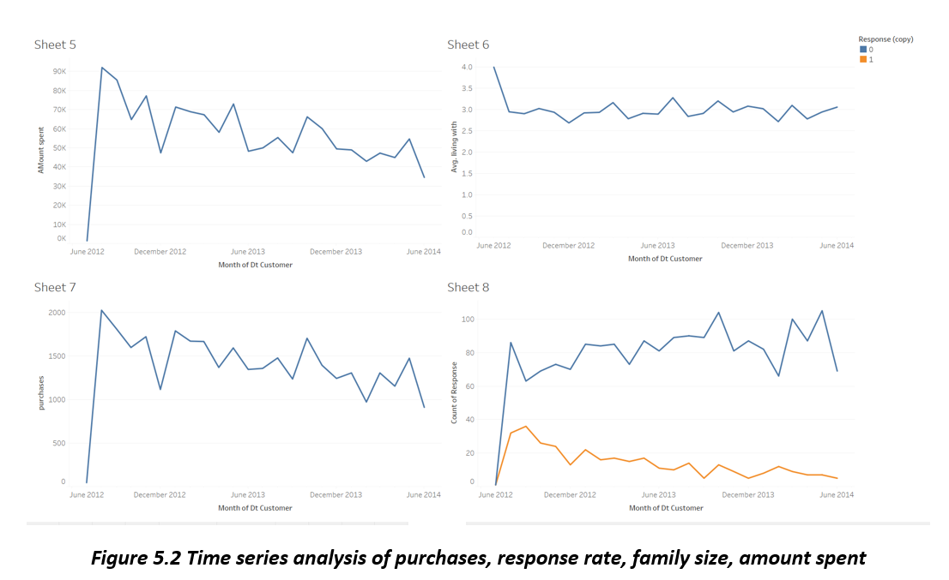

Created using Tableau
df['Marital_Status'].value_counts().plot(kind="bar")
<AxesSubplot:>
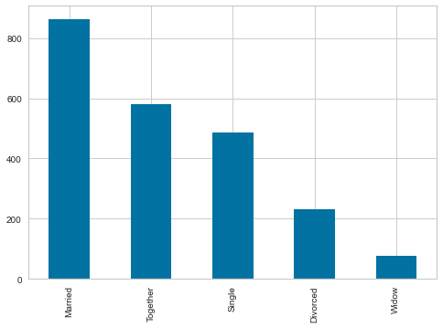
df["Education"].value_counts().plot(kind="bar")
<AxesSubplot:>
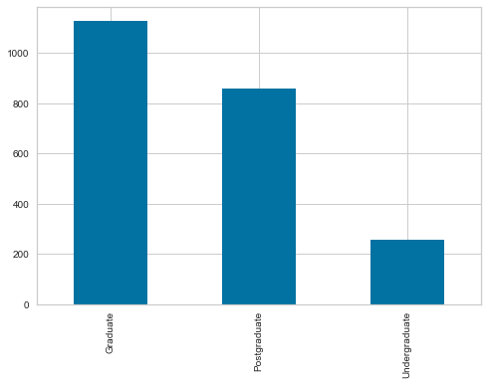
df.Income.plot(kind="hist")
<AxesSubplot:ylabel='Frequency'>
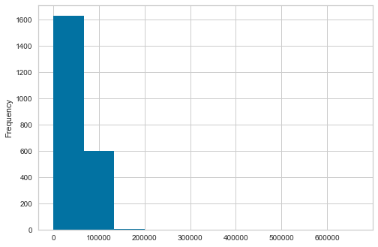
sns.boxplot(x=df['Income'])
<AxesSubplot:xlabel='Income'>
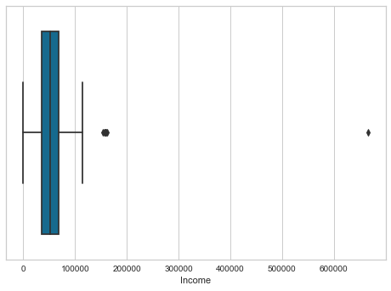
# we seem to have some outliers in our income feature . we will look at them in further exploration later
#Contigency tables
pd.crosstab([df["AcceptedCmp1"],df["AcceptedCmp2"],df["AcceptedCmp3"],df["AcceptedCmp4"],df["AcceptedCmp5"]],df["Living_With"],margins=True,margins_name='Grand Total')
Living_With Alone \
AcceptedCmp1 AcceptedCmp2 AcceptedCmp3 AcceptedCmp4 AcceptedCmp5
0 0 0 0 0 631
1 17
1 0 31
1 8
1 0 0 53
1 1
1 0 0 0 1
1 0 2
1 2
1 0 0 0
1 1
1 0 0 0 0 15
1 8
1 0 6
1 8
1 0 0 4
1 3
1 0 1 0 0
1 4
1 0 1 1
Grand Total 796
Living_With Partner \
AcceptedCmp1 AcceptedCmp2 AcceptedCmp3 AcceptedCmp4 AcceptedCmp5
0 0 0 0 0 1146
1 42
1 0 53
1 16
1 0 0 76
1 5
1 0 0 0 0
1 0 6
1 2
1 0 0 2
1 1
1 0 0 0 0 37
1 13
1 0 8
1 15
1 0 0 4
1 10
1 0 1 0 2
1 4
1 0 1 2
Grand Total 1444
Living_With Grand Total
AcceptedCmp1 AcceptedCmp2 AcceptedCmp3 AcceptedCmp4 AcceptedCmp5
0 0 0 0 0 1777
1 59
1 0 84
1 24
1 0 0 129
1 6
1 0 0 0 1
1 0 8
1 4
1 0 0 2
1 2
1 0 0 0 0 52
1 21
1 0 14
1 23
1 0 0 8
1 13
1 0 1 0 2
1 8
1 0 1 3
Grand Total 2240
# People prefer to accept 3rd offer more than others followed by 4th offer
# People in realtionships accept more offers than single people
plt.pie(x=df["Response"].value_counts(), autopct='%.0f%%',labels=[1,0])
([<matplotlib.patches.Wedge at 0x2673feaf1c0>,
<matplotlib.patches.Wedge at 0x2673feaf940>],
[Text(-0.981504079534704, 0.49663844178308797, '1'),
Text(0.9815040562853797, -0.4966384877306091, '0')],
[Text(-0.5353658615643839, 0.27089369551804793, '85%'),
Text(0.5353658488829344, -0.2708937205803322, '15%')])
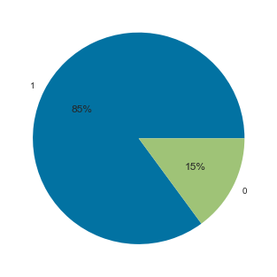
#85% of people responded no to our target variable
#dropped z_costContact and Z_revenue from main df
# No more analysis can be done
df.drop(['Z_CostContact','Z_Revenue'],axis=1,inplace=True)
df.info()
<class 'pandas.core.frame.DataFrame'>
RangeIndex: 2240 entries, 0 to 2239
Data columns (total 28 columns):
# Column Non-Null Count Dtype
--- ------ -------------- -----
0 ID 2240 non-null int64
1 Year_Birth 2240 non-null int64
2 Education 2240 non-null object
3 Marital_Status 2240 non-null object
4 Income 2240 non-null float64
5 Kidhome 2240 non-null int64
6 Teenhome 2240 non-null int64
7 Dt_Customer 2240 non-null datetime64[ns]
8 Recency 2240 non-null int64
9 MntWines 2240 non-null int64
10 MntFruits 2240 non-null int64
11 MntMeatProducts 2240 non-null int64
12 MntFishProducts 2240 non-null int64
13 MntSweetProducts 2240 non-null int64
14 MntGoldProds 2240 non-null int64
15 NumDealsPurchases 2240 non-null int64
16 NumWebPurchases 2240 non-null int64
17 NumCatalogPurchases 2240 non-null int64
18 NumStorePurchases 2240 non-null int64
19 NumWebVisitsMonth 2240 non-null int64
20 AcceptedCmp3 2240 non-null int64
21 AcceptedCmp4 2240 non-null int64
22 AcceptedCmp5 2240 non-null int64
23 AcceptedCmp1 2240 non-null int64
24 AcceptedCmp2 2240 non-null int64
25 Complain 2240 non-null int64
26 Response 2240 non-null int64
27 Living_With 2240 non-null object
dtypes: datetime64[ns](1), float64(1), int64(23), object(3)
memory usage: 490.1+ KB
numerics = ['int16', 'int32', 'int64', 'float16', 'float32', 'float64']
numericdf = df.select_dtypes(include=numerics)
#preparing dataframe for statistical analysis
numericdf.drop(["ID","Year_Birth","Kidhome","Teenhome","AcceptedCmp1","AcceptedCmp2","AcceptedCmp3","AcceptedCmp4","AcceptedCmp5","Response","Complain"],axis=1,inplace=True)
numericdf.describe()
Income Recency MntWines MntFruits MntMeatProducts \
count 2240.000 2240.000 2240.000 2240.000 2240.000
mean 51687.459 49.109 303.936 26.302 166.950
std 25609.343 28.962 336.597 39.773 225.715
min 0.000 0.000 0.000 0.000 0.000
25% 34722.000 24.000 23.750 1.000 16.000
50% 51075.000 49.000 173.500 8.000 67.000
75% 68289.750 74.000 504.250 33.000 232.000
max 666666.000 99.000 1493.000 199.000 1725.000
MntFishProducts MntSweetProducts MntGoldProds NumDealsPurchases \
count 2240.000 2240.000 2240.000 2240.000
mean 37.525 27.063 44.022 2.325
std 54.629 41.280 52.167 1.932
min 0.000 0.000 0.000 0.000
25% 3.000 1.000 9.000 1.000
50% 12.000 8.000 24.000 2.000
75% 50.000 33.000 56.000 3.000
max 259.000 263.000 362.000 15.000
NumWebPurchases NumCatalogPurchases NumStorePurchases \
count 2240.000 2240.000 2240.000
mean 4.085 2.662 5.790
std 2.779 2.923 3.251
min 0.000 0.000 0.000
25% 2.000 0.000 3.000
50% 4.000 2.000 5.000
75% 6.000 4.000 8.000
max 27.000 28.000 13.000
NumWebVisitsMonth
count 2240.000
mean 5.317
std 2.427
min 0.000
25% 3.000
50% 6.000
75% 7.000
max 20.000
#we can see on an average in recency a customer returns to store in every 50 days
#meat products beats its counter parts in average sales as well as maximum sale .
#indicating meat could be the most revenue generating product and we can target customers with high meat consumption more
#number of deals purchased from website and store is more . we can reduce focus on catalog purchases in future
# Box plots helps visualize outliers in the Products column
# Analyzing these outliers, we can find patterns within the ouliers of each plot and the can be used for further analysis
numericdf.plot(kind="box",subplots=True, layout=(5,3),figsize=(30,30))
Income AxesSubplot(0.125,0.749828;0.227941x0.130172)
Recency AxesSubplot(0.398529,0.749828;0.227941x0.130172)
MntWines AxesSubplot(0.672059,0.749828;0.227941x0.130172)
MntFruits AxesSubplot(0.125,0.593621;0.227941x0.130172)
MntMeatProducts AxesSubplot(0.398529,0.593621;0.227941x0.130172)
MntFishProducts AxesSubplot(0.672059,0.593621;0.227941x0.130172)
MntSweetProducts AxesSubplot(0.125,0.437414;0.227941x0.130172)
MntGoldProds AxesSubplot(0.398529,0.437414;0.227941x0.130172)
NumDealsPurchases AxesSubplot(0.672059,0.437414;0.227941x0.130172)
NumWebPurchases AxesSubplot(0.125,0.281207;0.227941x0.130172)
NumCatalogPurchases AxesSubplot(0.398529,0.281207;0.227941x0.130172)
NumStorePurchases AxesSubplot(0.672059,0.281207;0.227941x0.130172)
NumWebVisitsMonth AxesSubplot(0.125,0.125;0.227941x0.130172)
dtype: object
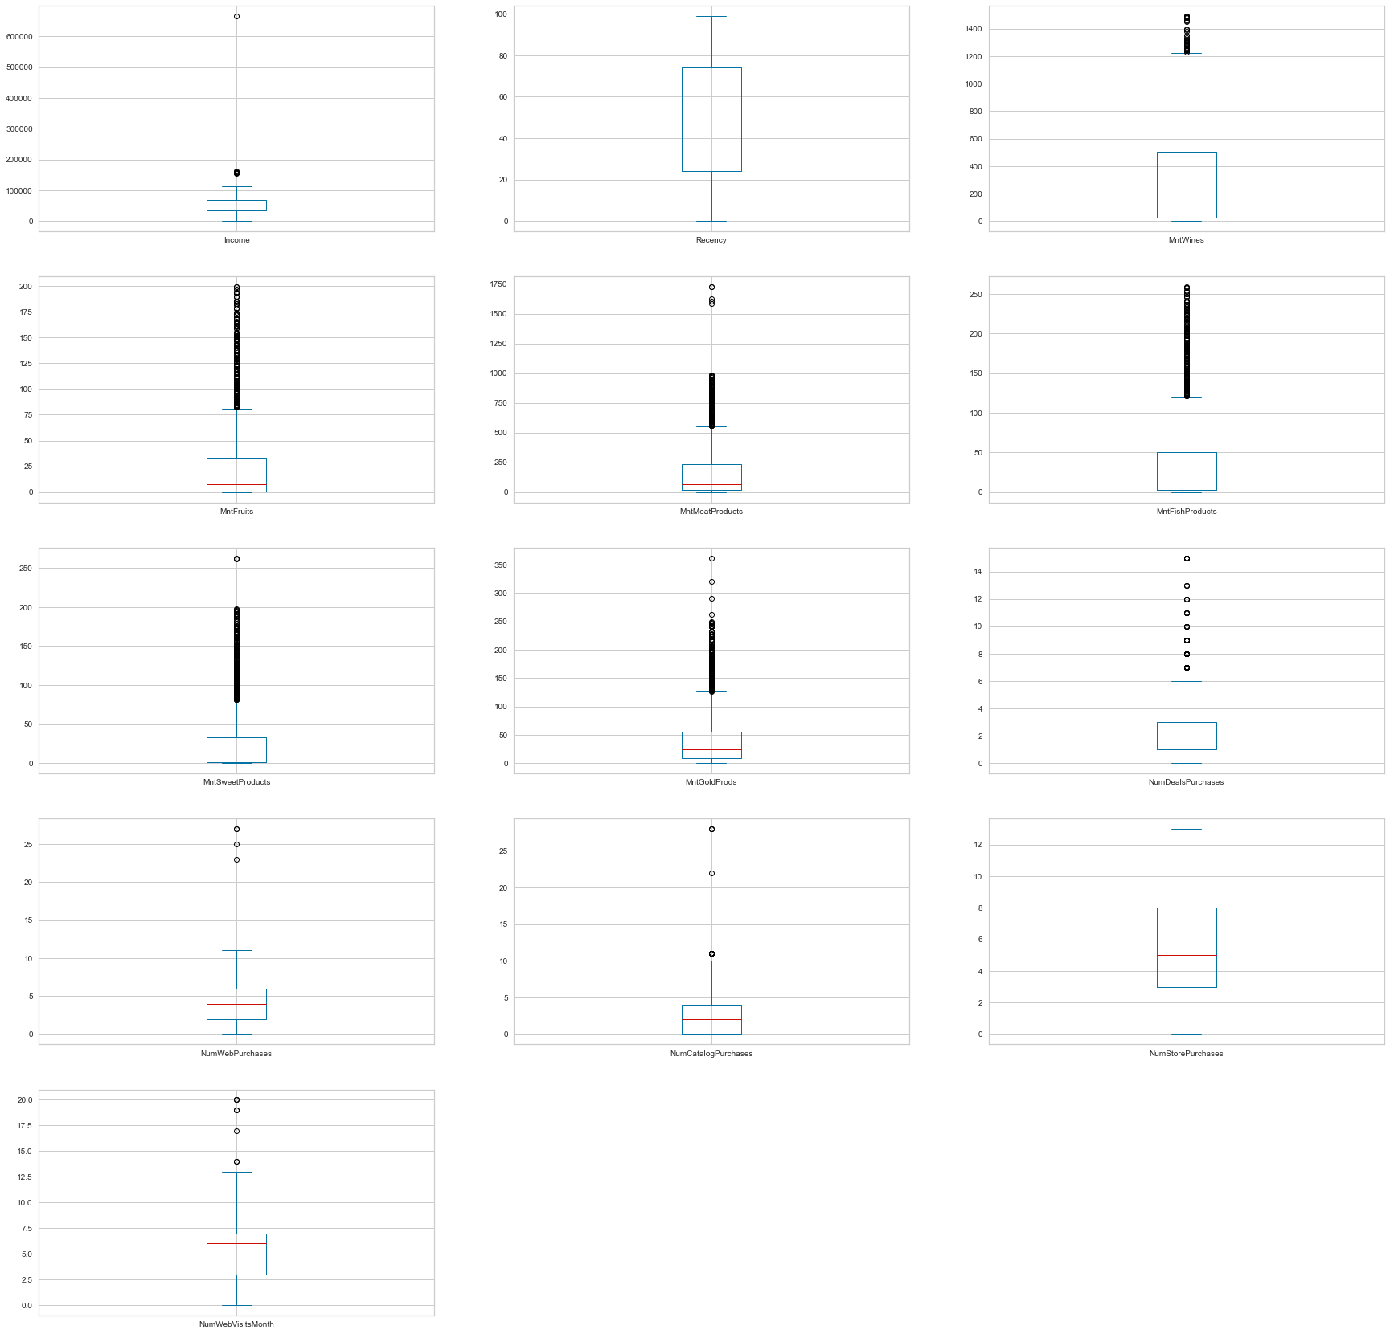
We notice that our dataset contains alot of outliers in every field. Clustering can be pretty effective in grouping these datas together to find a relation among them in further analysis
numericdf.kurtosis()
Income 147.940
Recency -1.202
MntWines 0.599
MntFruits 4.051
MntMeatProducts 5.517
MntFishProducts 3.096
MntSweetProducts 4.377
MntGoldProds 3.552
NumDealsPurchases 8.937
NumWebPurchases 5.703
NumCatalogPurchases 8.047
NumStorePurchases -0.622
NumWebVisitsMonth 1.822
dtype: float64
numericdf.skew()
Income 6.329
Recency -0.002
MntWines 1.176
MntFruits 2.102
MntMeatProducts 2.083
MntFishProducts 1.920
MntSweetProducts 2.136
MntGoldProds 1.886
NumDealsPurchases 2.419
NumWebPurchases 1.383
NumCatalogPurchases 1.881
NumStorePurchases 0.702
NumWebVisitsMonth 0.208
dtype: float64
numericdf2=numericdf.drop("Income",axis=1)
#lets try to visualize the distribution based on kurtosis and skewness
numericdf3=numericdf2.drop(["NumDealsPurchases","NumWebPurchases","NumCatalogPurchases","NumStorePurchases","NumWebVisitsMonth"],axis=1)
numericdf3.plot(kind='density',subplots=True,layout=(3,3),figsize=(20,20))
# The peaks seen in the plots shows similar kurtosis and we can analyze the overlapping values and outliers as such
array([[<AxesSubplot:ylabel='Density'>, <AxesSubplot:ylabel='Density'>,
<AxesSubplot:ylabel='Density'>],
[<AxesSubplot:ylabel='Density'>, <AxesSubplot:ylabel='Density'>,
<AxesSubplot:ylabel='Density'>],
[<AxesSubplot:ylabel='Density'>, <AxesSubplot:ylabel='Density'>,
<AxesSubplot:ylabel='Density'>]], dtype=object)
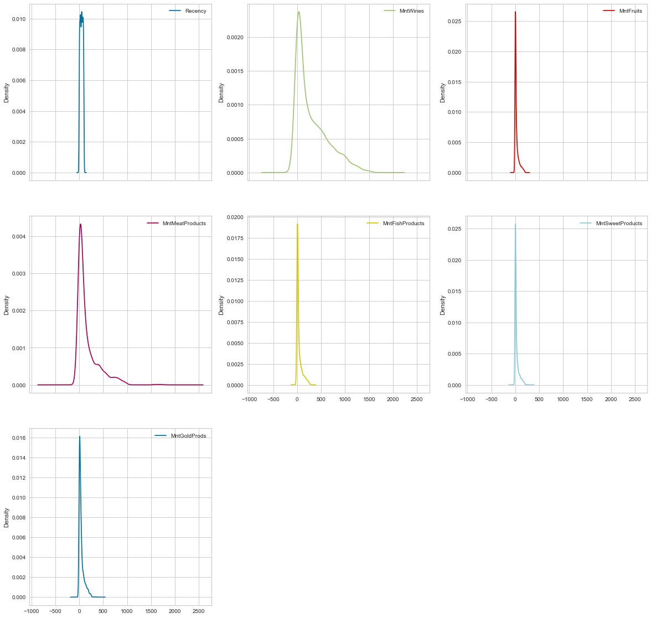
numericdf4=df[["NumDealsPurchases","NumWebPurchases","NumCatalogPurchases","NumStorePurchases","NumWebVisitsMonth"]]
numericdf4.plot(kind='density',subplots=True,layout=(3,3),figsize=(20,20))
array([[<AxesSubplot:ylabel='Density'>, <AxesSubplot:ylabel='Density'>,
<AxesSubplot:ylabel='Density'>],
[<AxesSubplot:ylabel='Density'>, <AxesSubplot:ylabel='Density'>,
<AxesSubplot:ylabel='Density'>],
[<AxesSubplot:ylabel='Density'>, <AxesSubplot:ylabel='Density'>,
<AxesSubplot:ylabel='Density'>]], dtype=object)
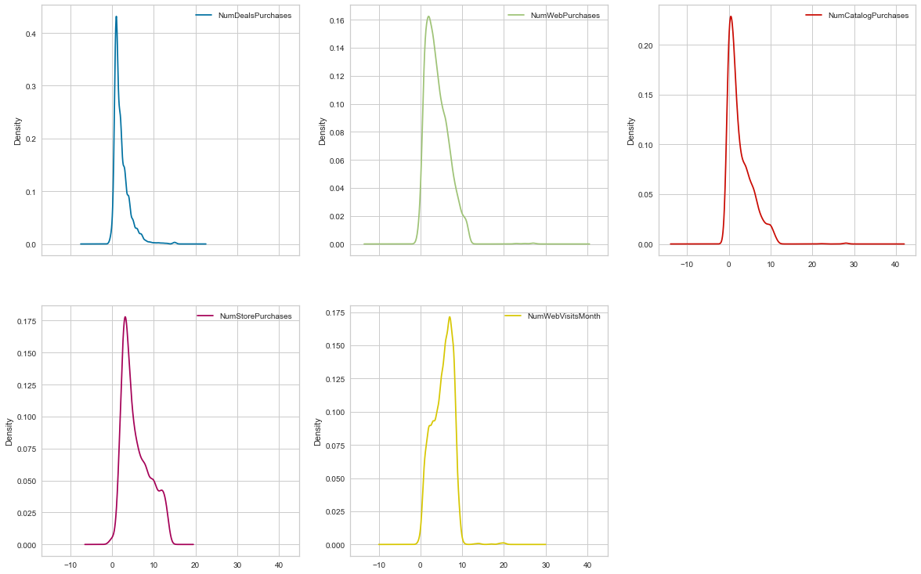
df["Income"].plot(kind="density")
<AxesSubplot:ylabel='Density'>
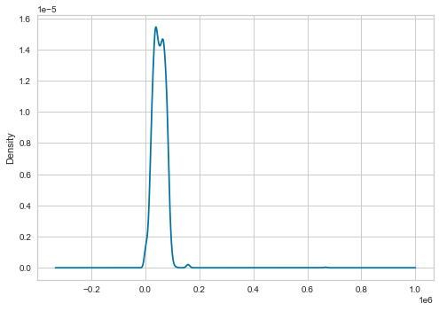
1- Recency seems to be clustered at one point with not much variation in data
2- products seem to be right tailed . indicating the number of customer buying in large quantities are more than customers who buy limited items. this can be interpreted as a positive sign for the store as these high buying customers would usually be the target of any promotion or such.
3- number of store purchases and catalog purchases seem to get us more business than other modes
#Created a feature "Customer_For"
df["Dt_Customer"] = pd.to_datetime(df["Dt_Customer"])
dates = []
for i in df["Dt_Customer"]:
i = i.date()
dates.append(i)
days = []
d1 = max(dates)
for i in dates:
delta = d1 - i
days.append(delta)
df["Customer_For"] = days
df["Customer_For"] = pd.to_numeric(df["Customer_For"], errors="coerce")
#Feature Engineering
#Age of customer today
df["Age"] = 2022-df["Year_Birth"]
#Total spendings on various items
df["Spent"] = df["MntWines"]+ df["MntFruits"]+ df["MntMeatProducts"]+ df["MntFishProducts"]+ df["MntSweetProducts"]+ df["MntGoldProds"]
#children at home
df["Children"]=df["Kidhome"]+df["Teenhome"]
#Feature for total members in the household
df["Family_Size"] = df["Living_With"].replace({"Alone": 1, "Partner":2})+ df["Children"]
#Feature showcasing parenthood
df["Is_Parent"] = np.where(df.Children> 0, 1, 0)
#For clarity
df=df.rename(columns={"MntWines": "Wines","MntFruits":"Fruits","MntMeatProducts":"Meat","MntFishProducts":"Fish","MntSweetProducts":"Sweets","MntGoldProds":"Gold"})
#Dropping some of the redundant features
to_drop = ["Marital_Status", "Dt_Customer", "Year_Birth", "ID"]
df = df.drop(to_drop, axis=1)
df.info()
<class 'pandas.core.frame.DataFrame'>
RangeIndex: 2240 entries, 0 to 2239
Data columns (total 30 columns):
# Column Non-Null Count Dtype
--- ------ -------------- -----
0 Education 2240 non-null object
1 Income 2240 non-null float64
2 Kidhome 2240 non-null int64
3 Teenhome 2240 non-null int64
4 Recency 2240 non-null int64
5 Wines 2240 non-null int64
6 Fruits 2240 non-null int64
7 Meat 2240 non-null int64
8 Fish 2240 non-null int64
9 Sweets 2240 non-null int64
10 Gold 2240 non-null int64
11 NumDealsPurchases 2240 non-null int64
12 NumWebPurchases 2240 non-null int64
13 NumCatalogPurchases 2240 non-null int64
14 NumStorePurchases 2240 non-null int64
15 NumWebVisitsMonth 2240 non-null int64
16 AcceptedCmp3 2240 non-null int64
17 AcceptedCmp4 2240 non-null int64
18 AcceptedCmp5 2240 non-null int64
19 AcceptedCmp1 2240 non-null int64
20 AcceptedCmp2 2240 non-null int64
21 Complain 2240 non-null int64
22 Response 2240 non-null int64
23 Living_With 2240 non-null object
24 Customer_For 2240 non-null int64
25 Age 2240 non-null int64
26 Spent 2240 non-null int64
27 Children 2240 non-null int64
28 Family_Size 2240 non-null int64
29 Is_Parent 2240 non-null int32
dtypes: float64(1), int32(1), int64(26), object(2)
memory usage: 516.4+ KB
df.describe()
Income Kidhome Teenhome Recency Wines Fruits Meat \
count 2240.000 2240.000 2240.000 2240.000 2240.000 2240.000 2240.000
mean 51687.459 0.444 0.506 49.109 303.936 26.302 166.950
std 25609.343 0.538 0.545 28.962 336.597 39.773 225.715
min 0.000 0.000 0.000 0.000 0.000 0.000 0.000
25% 34722.000 0.000 0.000 24.000 23.750 1.000 16.000
50% 51075.000 0.000 0.000 49.000 173.500 8.000 67.000
75% 68289.750 1.000 1.000 74.000 504.250 33.000 232.000
max 666666.000 2.000 2.000 99.000 1493.000 199.000 1725.000
Fish Sweets Gold NumDealsPurchases NumWebPurchases \
count 2240.000 2240.000 2240.000 2240.000 2240.000
mean 37.525 27.063 44.022 2.325 4.085
std 54.629 41.280 52.167 1.932 2.779
min 0.000 0.000 0.000 0.000 0.000
25% 3.000 1.000 9.000 1.000 2.000
50% 12.000 8.000 24.000 2.000 4.000
75% 50.000 33.000 56.000 3.000 6.000
max 259.000 263.000 362.000 15.000 27.000
NumCatalogPurchases NumStorePurchases NumWebVisitsMonth \
count 2240.000 2240.000 2240.000
mean 2.662 5.790 5.317
std 2.923 3.251 2.427
min 0.000 0.000 0.000
25% 0.000 3.000 3.000
50% 2.000 5.000 6.000
75% 4.000 8.000 7.000
max 28.000 13.000 20.000
AcceptedCmp3 AcceptedCmp4 AcceptedCmp5 AcceptedCmp1 AcceptedCmp2 \
count 2240.000 2240.000 2240.000 2240.000 2240.000
mean 0.073 0.075 0.073 0.064 0.013
std 0.260 0.263 0.260 0.245 0.115
min 0.000 0.000 0.000 0.000 0.000
25% 0.000 0.000 0.000 0.000 0.000
50% 0.000 0.000 0.000 0.000 0.000
75% 0.000 0.000 0.000 0.000 0.000
max 1.000 1.000 1.000 1.000 1.000
Complain Response Customer_For Age Spent Children \
count 2240.000 2240.000 2240.000 2240.000 2240.000 2240.000
mean 0.009 0.149 30549497142857144.000 53.194 605.798 0.950
std 0.096 0.356 17463385066913898.000 11.984 602.249 0.752
min 0.000 0.000 0.000 26.000 5.000 0.000
25% 0.000 0.000 15616800000000000.000 45.000 68.750 0.000
50% 0.000 0.000 30715200000000000.000 52.000 396.000 1.000
75% 0.000 0.000 45705600000000000.000 63.000 1045.500 1.000
max 1.000 1.000 60393600000000000.000 129.000 2525.000 3.000
Family_Size Is_Parent
count 2240.000 2240.000
mean 2.595 0.715
std 0.907 0.451
min 1.000 0.000
25% 2.000 0.000
50% 3.000 1.000
75% 3.000 1.000
max 5.000 1.000
#there is one outlier in income and age, the outlier is of no use for future analysis
print(np.where(df.Income>500000))
(array([2233], dtype=int64),)
print(df.iloc[2233])
# iloc removes the respective index value of the outlier as gathered from the last step
Education Graduate
Income 666666.000
Kidhome 1
Teenhome 0
Recency 23
Wines 9
Fruits 14
Meat 18
Fish 8
Sweets 1
Gold 12
NumDealsPurchases 4
NumWebPurchases 3
NumCatalogPurchases 1
NumStorePurchases 3
NumWebVisitsMonth 6
AcceptedCmp3 0
AcceptedCmp4 0
AcceptedCmp5 0
AcceptedCmp1 0
AcceptedCmp2 0
Complain 0
Response 0
Living_With Partner
Customer_For 33868800000000000
Age 45
Spent 62
Children 1
Family_Size 3
Is_Parent 1
Name: 2233, dtype: object
#as our income outlier doesnt have any special characteristic to it . we would be dropping it
df = df[(df["Age"]<90)]
df = df[(df["Income"]<600000)]
corrmat= df.corr()
plt.figure(figsize=(20,20))
sns.heatmap(corrmat,annot=True, center=0)
<AxesSubplot:>
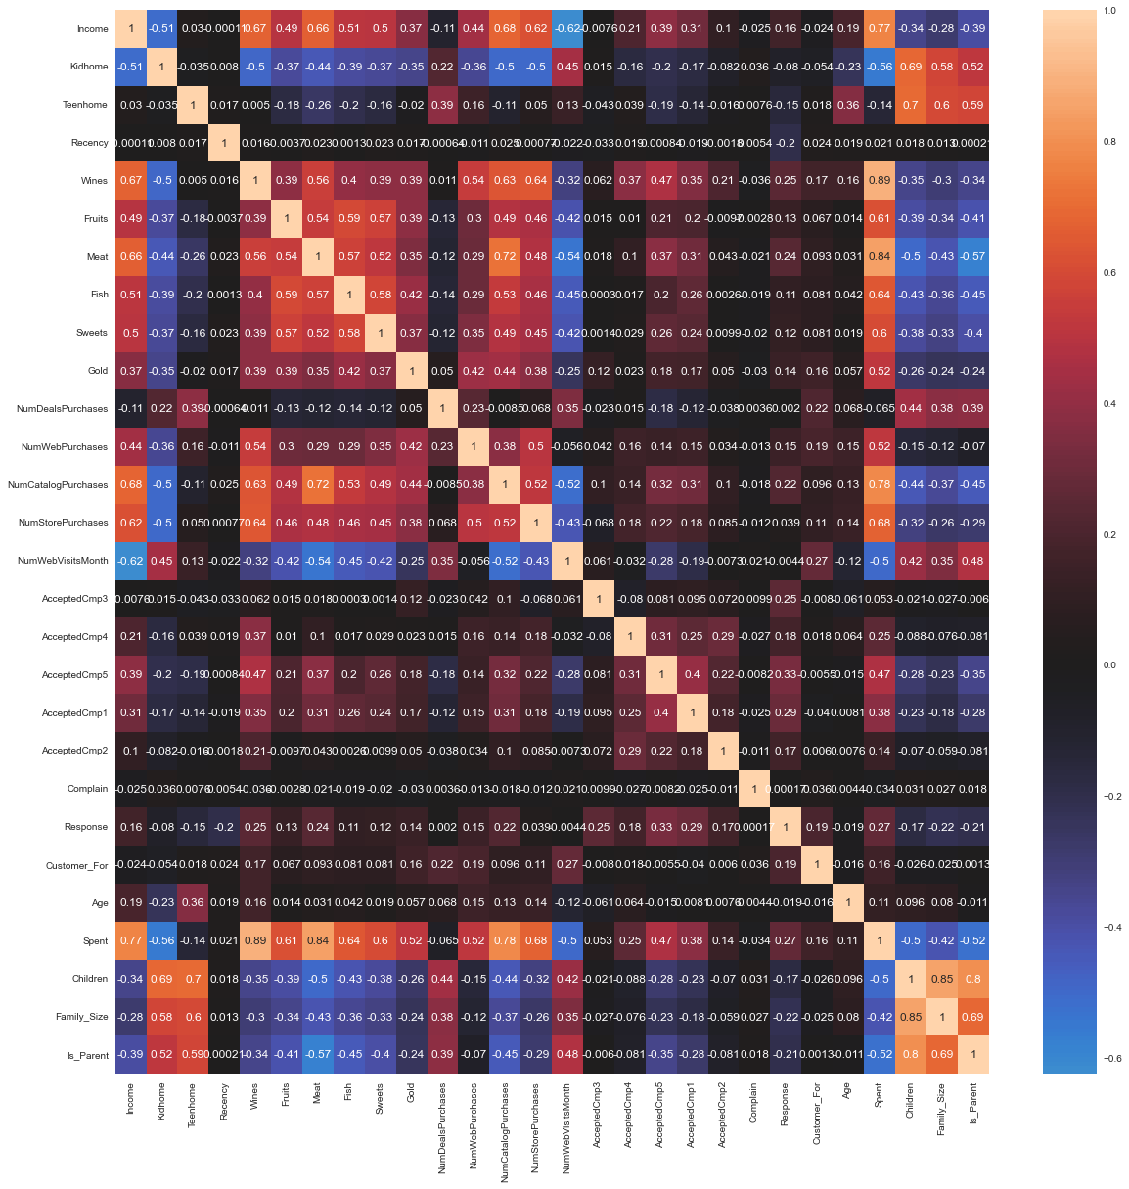
Response variable shows correlation to high spending and customers who acceptcomp5
wines, fish , number of web and catalogue purchaces show relation with high spending customers
parents tend to spend less
Our target customers have to be high spenders . We would further analyse what factors would include high spending customers during our clustering
import datetime
import matplotlib
from matplotlib import colors
from sklearn.preprocessing import LabelEncoder
from sklearn.preprocessing import StandardScaler
from sklearn.decomposition import PCA
from yellowbrick.cluster import KElbowVisualizer
from sklearn.cluster import KMeans
import matplotlib.pyplot as plt, numpy as np
from mpl_toolkits.mplot3d import Axes3D
from sklearn.cluster import AgglomerativeClustering
from matplotlib.colors import ListedColormap
from sklearn import metrics
import warnings
import sys
if not sys.warnoptions:
warnings.simplefilter("ignore")
np.random.seed(42)
s = (df.dtypes == 'object')
object_cols = list(s[s].index)
LE=LabelEncoder()
for i in object_cols:
df[i]=df[[i]].apply(LE.fit_transform)
print(df.head(5))
Education Income Kidhome Teenhome Recency Wines Fruits Meat Fish \
0 0 58138.000 0 0 58 635 88 546 172
1 0 46344.000 1 1 38 11 1 6 2
2 0 71613.000 0 0 26 426 49 127 111
3 0 26646.000 1 0 26 11 4 20 10
4 1 58293.000 1 0 94 173 43 118 46
Sweets Gold NumDealsPurchases NumWebPurchases NumCatalogPurchases \
0 88 88 3 8 10
1 1 6 2 1 1
2 21 42 1 8 2
3 3 5 2 2 0
4 27 15 5 5 3
NumStorePurchases NumWebVisitsMonth AcceptedCmp3 AcceptedCmp4 \
0 4 7 0 0
1 2 5 0 0
2 10 4 0 0
3 4 6 0 0
4 6 5 0 0
AcceptedCmp5 AcceptedCmp1 AcceptedCmp2 Complain Response Living_With \
0 0 0 0 0 1 0
1 0 0 0 0 0 0
2 0 0 0 0 0 1
3 0 0 0 0 0 1
4 0 0 0 0 0 1
Customer_For Age Spent Children Family_Size Is_Parent
0 57283200000000000 65 1617 0 1 0
1 9763200000000000 68 27 2 3 1
2 26956800000000000 57 776 0 2 0
3 12009600000000000 38 53 1 3 1
4 13910400000000000 41 422 1 3 1
Preprocessing Data for Clustering
Converted data into numeric values
df.info()
df['Living_With'].head(5)
<class 'pandas.core.frame.DataFrame'>
Int64Index: 2236 entries, 0 to 2239
Data columns (total 30 columns):
# Column Non-Null Count Dtype
--- ------ -------------- -----
0 Education 2236 non-null int32
1 Income 2236 non-null float64
2 Kidhome 2236 non-null int64
3 Teenhome 2236 non-null int64
4 Recency 2236 non-null int64
5 Wines 2236 non-null int64
6 Fruits 2236 non-null int64
7 Meat 2236 non-null int64
8 Fish 2236 non-null int64
9 Sweets 2236 non-null int64
10 Gold 2236 non-null int64
11 NumDealsPurchases 2236 non-null int64
12 NumWebPurchases 2236 non-null int64
13 NumCatalogPurchases 2236 non-null int64
14 NumStorePurchases 2236 non-null int64
15 NumWebVisitsMonth 2236 non-null int64
16 AcceptedCmp3 2236 non-null int64
17 AcceptedCmp4 2236 non-null int64
18 AcceptedCmp5 2236 non-null int64
19 AcceptedCmp1 2236 non-null int64
20 AcceptedCmp2 2236 non-null int64
21 Complain 2236 non-null int64
22 Response 2236 non-null int64
23 Living_With 2236 non-null int32
24 Customer_For 2236 non-null int64
25 Age 2236 non-null int64
26 Spent 2236 non-null int64
27 Children 2236 non-null int64
28 Family_Size 2236 non-null int64
29 Is_Parent 2236 non-null int32
dtypes: float64(1), int32(3), int64(26)
memory usage: 515.3 KB
0 0
1 0
2 1
3 1
4 1
Name: Living_With, dtype: int32
ds = df.copy()
# creating a subset of dataframe by dropping the features on deals accepted and promotions
cols_del = ['AcceptedCmp3', 'AcceptedCmp4', 'AcceptedCmp5', 'AcceptedCmp1','AcceptedCmp2', 'Complain', 'Response']
ds = ds.drop(cols_del, axis=1)
#Scaling
scaler = StandardScaler()
scaler.fit(ds)
scaled_ds = pd.DataFrame(scaler.transform(ds),columns= ds.columns )
(scaled_ds.head(10))
Education Income Kidhome Teenhome Recency Wines Fruits Meat Fish \
0 -0.894 0.305 -0.825 -0.931 0.307 0.983 1.554 1.680 2.461
1 -0.894 -0.229 1.033 0.906 -0.384 -0.871 -0.636 -0.713 -0.650
2 -0.894 0.916 -0.825 -0.931 -0.798 0.362 0.572 -0.177 1.345
3 -0.894 -1.122 1.033 -0.931 -0.798 -0.871 -0.561 -0.651 -0.504
4 0.571 0.312 1.033 -0.931 1.550 -0.390 0.421 -0.217 0.155
5 0.571 0.504 -0.825 0.906 -1.144 0.641 0.396 -0.306 -0.687
6 -0.894 0.192 -0.825 0.906 -0.522 -0.205 0.975 -0.013 0.228
7 0.571 -0.813 1.033 -0.931 -0.591 -0.678 -0.410 -0.492 -0.632
8 0.571 -0.954 1.033 -0.931 -1.040 -0.862 -0.662 -0.634 -0.632
9 0.571 -2.073 1.033 0.906 0.652 -0.821 -0.662 -0.713 -0.669
Sweets Gold NumDealsPurchases NumWebPurchases NumCatalogPurchases \
0 1.475 0.846 0.349 1.408 2.510
1 -0.632 -0.730 -0.169 -1.111 -0.569
2 -0.147 -0.038 -0.686 1.408 -0.227
3 -0.583 -0.749 -0.169 -0.751 -0.911
4 -0.002 -0.557 1.384 0.328 0.115
5 0.361 -0.576 -0.169 0.688 0.457
6 0.531 -0.326 0.866 1.048 0.115
7 -0.632 -0.403 -0.169 -0.032 -0.911
8 -0.583 -0.807 -0.686 -0.391 -0.911
9 -0.632 -0.595 -0.686 -1.111 -0.911
NumStorePurchases NumWebVisitsMonth Living_With Customer_For Age \
0 -0.552 0.693 -1.348 1.530 1.017
1 -1.168 -0.131 -1.348 -1.191 1.273
2 1.293 -0.544 0.742 -0.207 0.333
3 -0.552 0.281 0.742 -1.063 -1.291
4 0.063 -0.131 0.742 -0.954 -1.034
5 1.293 0.281 0.742 -0.301 0.162
6 0.371 0.281 -1.348 1.183 -0.180
7 -0.552 1.105 0.742 0.313 -1.376
8 -1.168 1.517 0.742 0.169 -0.436
9 -1.783 6.051 0.742 -1.216 1.615
Spent Children Family_Size Is_Parent
0 1.680 -1.264 -1.759 -1.584
1 -0.962 1.395 0.446 0.631
2 0.283 -1.264 -0.657 -1.584
3 -0.919 0.065 0.446 0.631
4 -0.306 0.065 0.446 0.631
5 0.183 0.065 0.446 0.631
6 -0.027 0.065 -0.657 0.631
7 -0.726 0.065 0.446 0.631
8 -0.931 0.065 0.446 0.631
9 -0.926 1.395 1.548 0.631
Scaling Data
# dimensionality reduction
# Four dimensions created col1, col2, col3 and col4
# col1, col2 and col3 represents the three axes x, y and z in a graph. col4 is the the size of the plotting in the chart.
pca = PCA(n_components=4)
pca.fit(scaled_ds)
PCA_ds=pd.DataFrame(pca.transform(scaled_ds), columns=(['col1','col2','col3','col4']))
PCA_ds.describe().T
count mean std min 25% 50% 75% max
col1 2236.000 -0.000 2.869 -5.945 -2.515 -0.782 2.370 7.451
col2 2236.000 0.000 1.708 -4.189 -1.317 -0.175 1.221 6.139
col3 2236.000 0.000 1.228 -3.576 -0.834 -0.066 0.866 6.669
col4 2236.000 0.000 1.147 -3.132 -0.757 -0.012 0.894 3.368
x=PCA_ds['col1']
y=PCA_ds['col2']
z=PCA_ds['col3']
p=PCA_ds['col4']
fig=plt.figure(figsize=(10,10))
ax=fig.add_subplot(111,projection='3d')
ax=ax.scatter(x,y,z,s=p*40,c='red', marker='o')
plt.show()
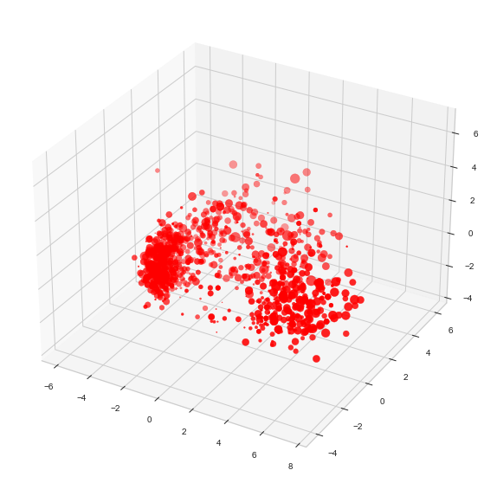
Visual Representation of our PCA component
from yellowbrick.cluster import KElbowVisualizer
# The green line in the plot specifies the time needed by the clustering process
# Less time with good distortion score is optimal for this dataset, ie 4 optimal clusters
Elbow_M = KElbowVisualizer(KMeans(), k=10)
Elbow_M.fit(PCA_ds)
Elbow_M.show()
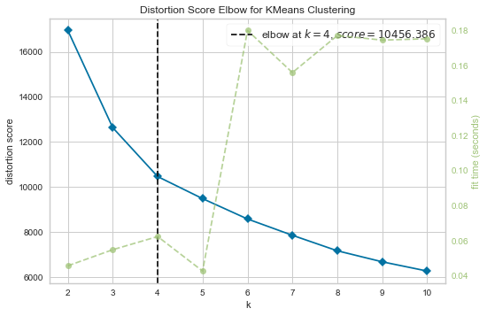
<AxesSubplot:title={'center':'Distortion Score Elbow for KMeans Clustering'}, xlabel='k', ylabel='distortion score'>
# Next, we will be fitting the Agglomerative Clustering Model to get the final clusters.
AC = AgglomerativeClustering(n_clusters=4)
# fit model and predict clusters
yhat_AC = AC.fit_predict(PCA_ds)
PCA_ds["Clusters"] = yhat_AC
#Adding the Clusters feature to the orignal dataframe.
df["Clusters"]= yhat_AC
from matplotlib import cm
fig = plt.figure(figsize=(10,8))
ax = plt.subplot(111, projection='3d', label="bla")
ax.scatter(x, y, z, s=p*40, c=PCA_ds["Clusters"], marker='o',cmap=cm.inferno)
plt.show()
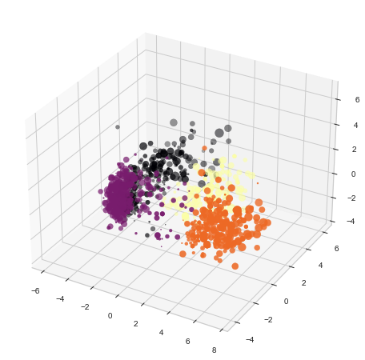
pal = ["#682F2F","#B9C0C9", "#9F8A78","#F3AB60"]
pl = sns.countplot(x=df["Clusters"], palette= pal)
pl.set_title("Distribution Of The Clusters")
plt.show()
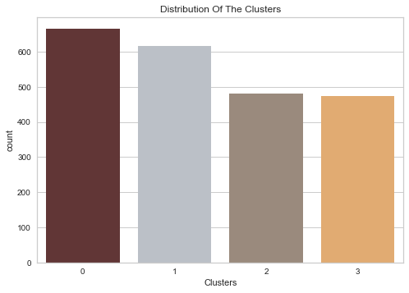
Cluster 0 and 1 form our most customers
pl = sns.scatterplot(data = df,x=df["Spent"], y=df["Income"],hue=df["Clusters"], palette= pal)
plt.legend()
plt.show()
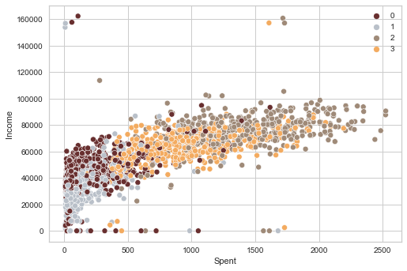

group 3: high spending & average income

group 2: high spending & high income

group 1: low spending & low income

group 0: low spending & average income
plt.figure()
pl=sns.swarmplot(x=df["Clusters"], y=df["Spent"], color= "#CBEDDD", alpha=0.5 )
pl=sns.boxenplot(x=df["Clusters"], y=df["Spent"], palette=pal)
plt.show()
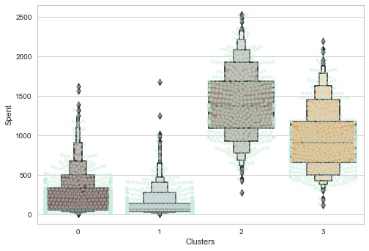
This indicates clusters 2 and 3 are high spending customers which is consistent with our clusters visualized above
df["Total_Promos"] = df["AcceptedCmp1"]+ df["AcceptedCmp2"]+ df["AcceptedCmp3"]+ df["AcceptedCmp4"]+ df["AcceptedCmp5"]
#Plotting count of total campaign accepted.
plt.figure()
pl = sns.countplot(x=df["Total_Promos"],hue=df["Clusters"], palette= pal)
pl.set_title("Count Of Promotion Accepted")
pl.set_xlabel("Number Of Total Accepted Promotions")
plt.show()
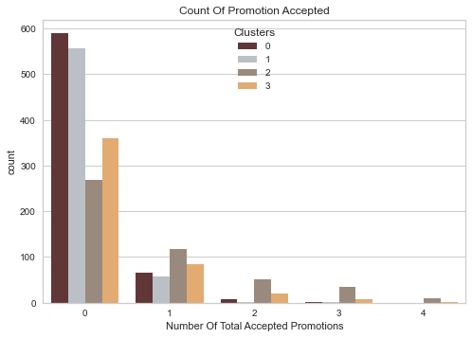
# Cluster 2 and 3 (high spending) tend to always accept promotions while 0 & 1 clusters dont
plt.figure()
pl=sns.boxenplot(y=df["NumDealsPurchases"],x=df["Clusters"], palette= pal)
pl.set_title("Number of Deals Purchased")
plt.show()
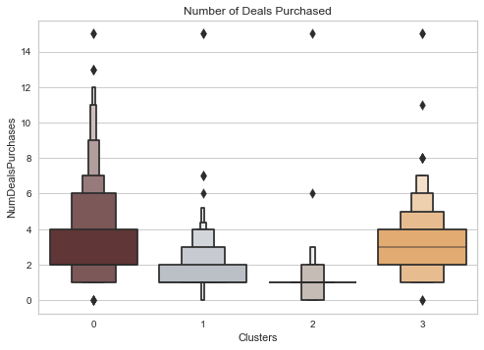
# The boxen plots shows how much a person or a family spends if they have a kid at home, teenage at home, age, children atleast 1
# Spent with respect to Education, living_with and the feature customer_for
Personal = [ "Kidhome","Teenhome","Customer_For", "Age", "Children", "Family_Size", "Is_Parent", "Education","Living_With"]
for i in Personal:
plt.figure()
sns.jointplot(x=df[i], y=df["Spent"], hue =df["Clusters"], kind="kde", palette=pal)
plt.show()
<Figure size 576x396 with 0 Axes>
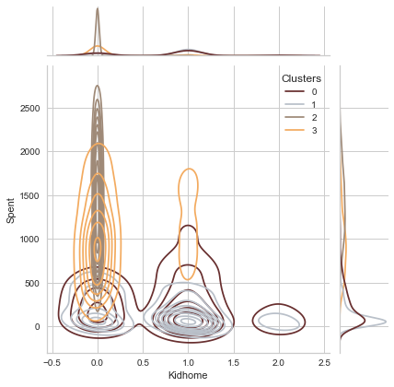
<Figure size 576x396 with 0 Axes>
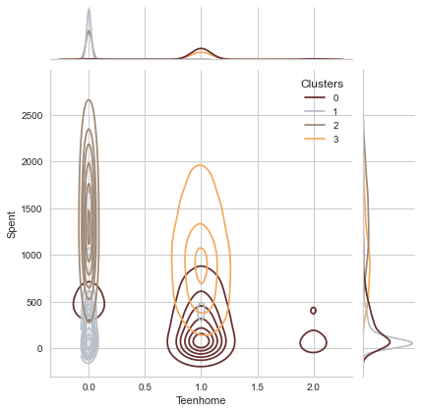
<Figure size 576x396 with 0 Axes>
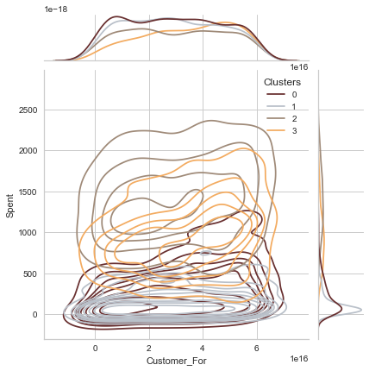
<Figure size 576x396 with 0 Axes>
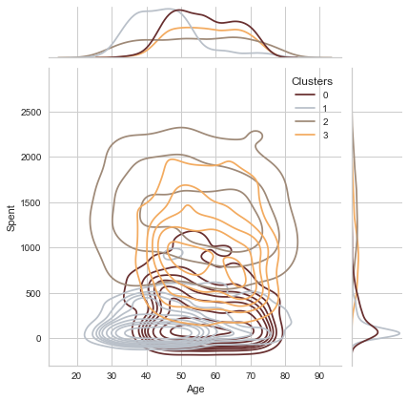
<Figure size 576x396 with 0 Axes>
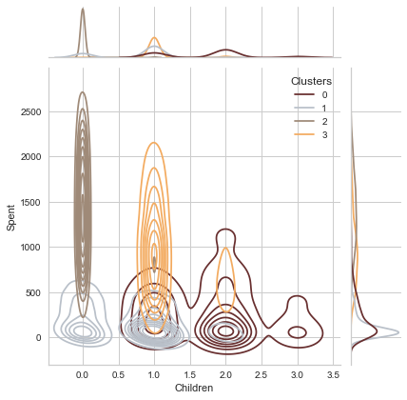
<Figure size 576x396 with 0 Axes>
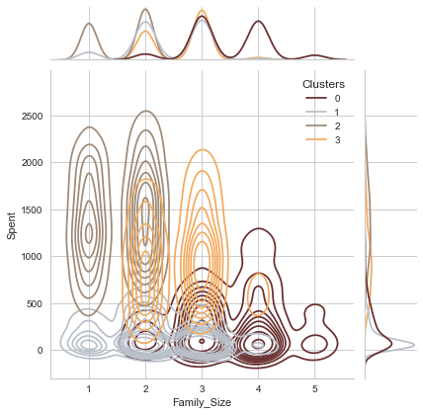
<Figure size 576x396 with 0 Axes>
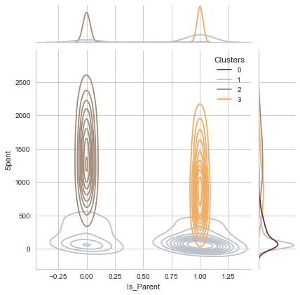
<Figure size 576x396 with 0 Axes>
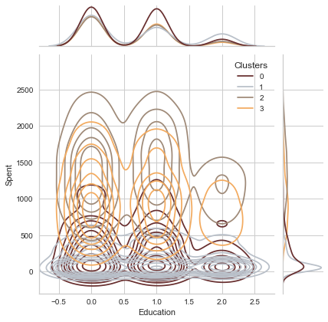
<Figure size 576x396 with 0 Axes>
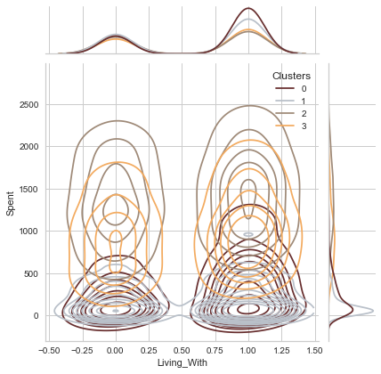
Personal = [ "Wines","Fruits","Meat", "Fish", "Sweets", "Gold"]
for i in Personal:
plt.figure()
sns.jointplot(x=df[i], y=df["Spent"], hue =df["Clusters"], kind="kde", palette=pal)
plt.show()
<Figure size 576x396 with 0 Axes>
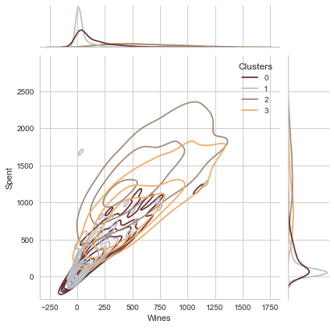
<Figure size 576x396 with 0 Axes>
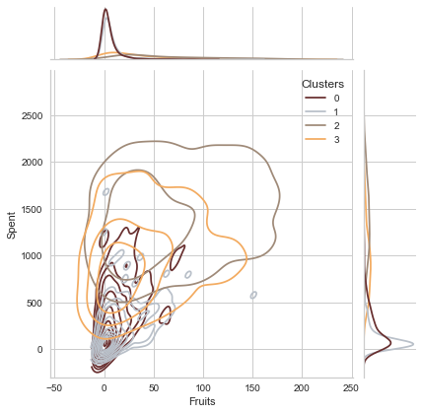
<Figure size 576x396 with 0 Axes>
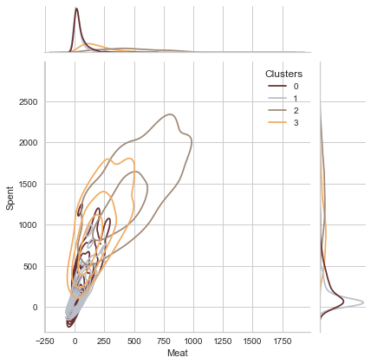
<Figure size 576x396 with 0 Axes>
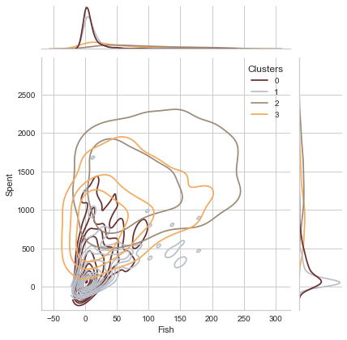
<Figure size 576x396 with 0 Axes>
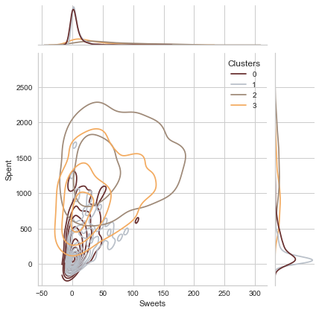
<Figure size 576x396 with 0 Axes>
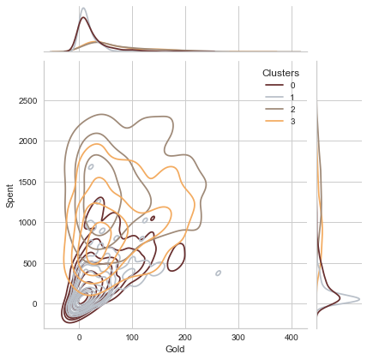
The above visualizations help us identify and summarize the profile of each clusters based on their density in the respective feature values
eg - in first graph above, Kidhome is on x-axis we notice that cluster 2 and 3 are more dense at '0' indicating theyre less likely to be parents of kids
but in second graph, cluster 2 is again dense at 0 indicating customers in cluster 2 are definetely not parents. but cluster 1 customer are more likely to have kids but not teenagers at home where as cluster definetely have a teen at home
Such analysis have been drawn from all these plots and summarized in conclusion for profiling below
corrmat= df.corr()
plt.figure(figsize=(20,20))
sns.heatmap(corrmat,annot=True, center=0)
<AxesSubplot:>
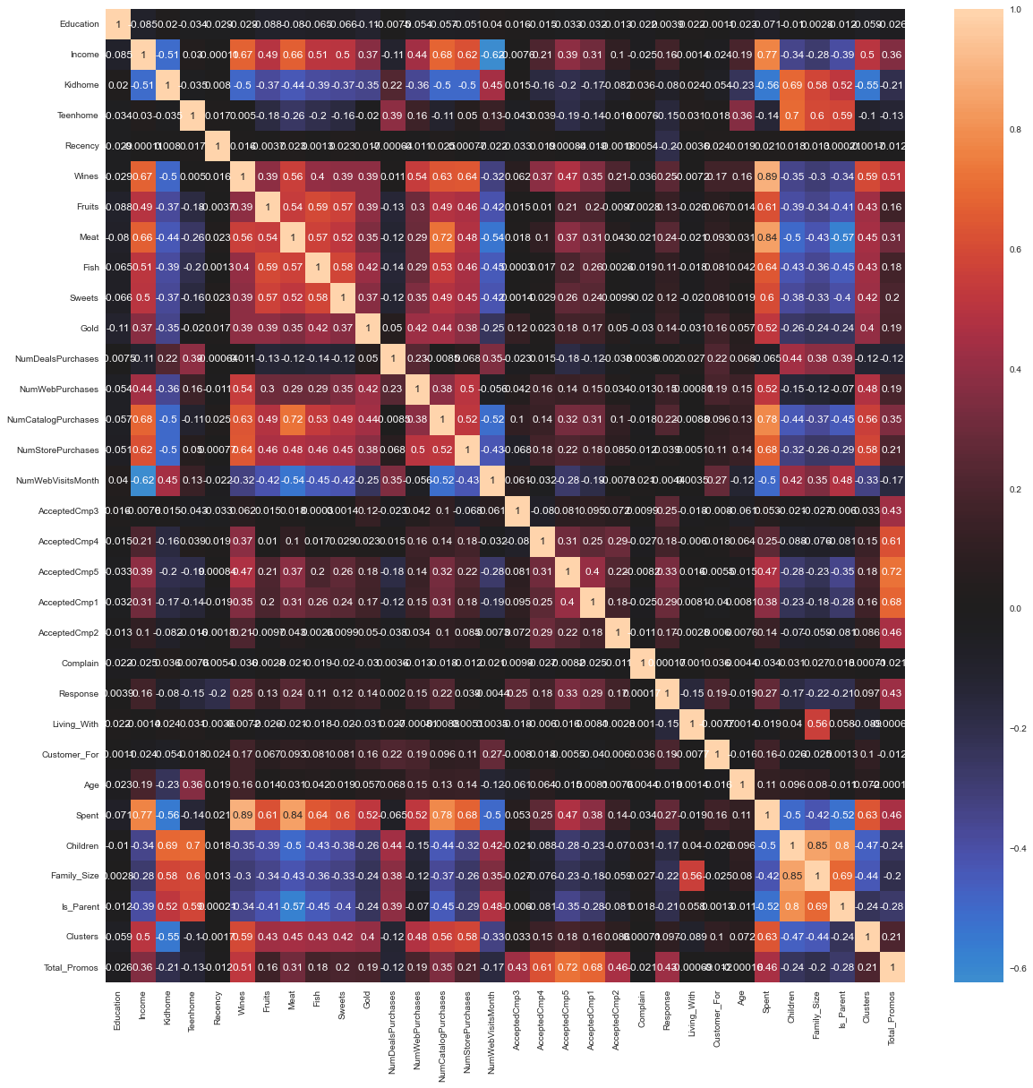
Heatmap to check if the relation in our profiles are consistent with correlation
eg- it can be identified that spent is highly correlated with the sales of different products which was also indicated by the clusters distribution above in jointplots
fig = plt.figure(figsize=(10,8))
ax = plt.subplot(111, projection='3d', label="bla")
ax.scatter( df['Customer_For'],df['Spent'], df['Income'], s=p*40, c=PCA_ds["Clusters"], marker='o',cmap=cm.inferno)
plt.show()
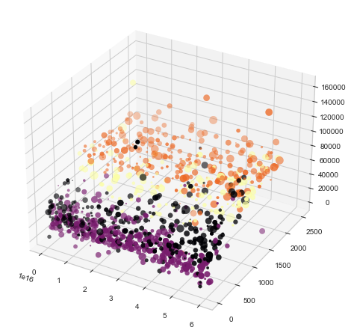

Visualization of our clusters in 3D
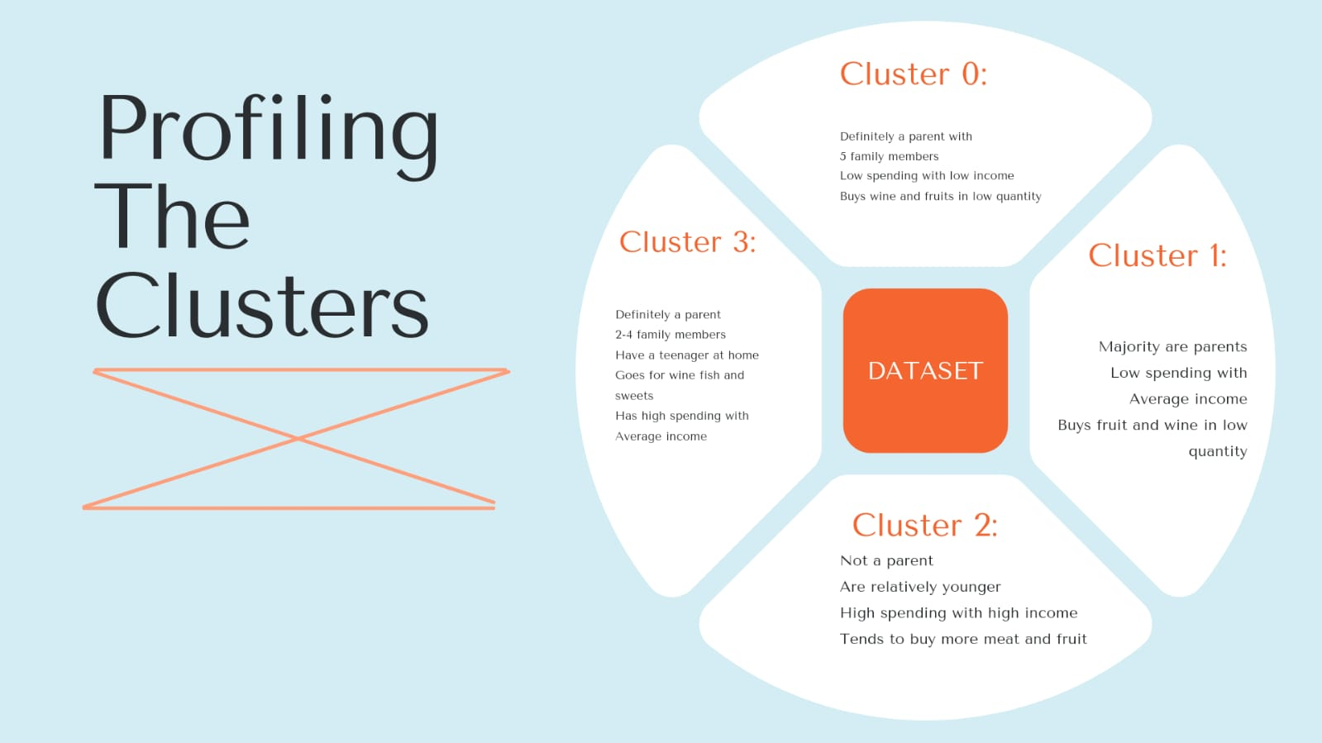
Final conclusion of Customer Profiling
df.info()
<class 'pandas.core.frame.DataFrame'>
Int64Index: 2236 entries, 0 to 2239
Data columns (total 32 columns):
# Column Non-Null Count Dtype
--- ------ -------------- -----
0 Education 2236 non-null int32
1 Income 2236 non-null float64
2 Kidhome 2236 non-null int64
3 Teenhome 2236 non-null int64
4 Recency 2236 non-null int64
5 Wines 2236 non-null int64
6 Fruits 2236 non-null int64
7 Meat 2236 non-null int64
8 Fish 2236 non-null int64
9 Sweets 2236 non-null int64
10 Gold 2236 non-null int64
11 NumDealsPurchases 2236 non-null int64
12 NumWebPurchases 2236 non-null int64
13 NumCatalogPurchases 2236 non-null int64
14 NumStorePurchases 2236 non-null int64
15 NumWebVisitsMonth 2236 non-null int64
16 AcceptedCmp3 2236 non-null int64
17 AcceptedCmp4 2236 non-null int64
18 AcceptedCmp5 2236 non-null int64
19 AcceptedCmp1 2236 non-null int64
20 AcceptedCmp2 2236 non-null int64
21 Complain 2236 non-null int64
22 Response 2236 non-null int64
23 Living_With 2236 non-null int32
24 Customer_For 2236 non-null int64
25 Age 2236 non-null int64
26 Spent 2236 non-null int64
27 Children 2236 non-null int64
28 Family_Size 2236 non-null int64
29 Is_Parent 2236 non-null int32
30 Clusters 2236 non-null int64
31 Total_Promos 2236 non-null int64
dtypes: float64(1), int32(3), int64(28)
memory usage: 614.8 KB
# Coverting every column into numerical values from categorical
df2.Living_With=df.Living_With.map({0:"Alone",1:'Couple'})
df2.Is_Parent=df.Is_Parent.map({0:"No Child",1:'Has Child'})
df2.head(20)
Education Living_With Spent Children Is_Parent Wines Fruits Meat \
0 0 Alone 1617 0 No Child 635 88 546
1 0 Alone 27 2 Has Child 11 1 6
2 0 Couple 776 0 No Child 426 49 127
3 0 Couple 53 1 Has Child 11 4 20
4 1 Couple 422 1 Has Child 173 43 118
5 1 Couple 716 1 Has Child 520 42 98
6 0 Alone 590 1 Has Child 235 65 164
7 1 Couple 169 1 Has Child 76 10 56
8 1 Couple 46 1 Has Child 14 0 24
9 1 Couple 49 2 Has Child 28 0 6
10 0 Couple 19 1 Has Child 5 5 6
11 2 Couple 61 0 No Child 6 16 11
12 0 Alone 1102 0 No Child 194 61 480
13 1 Alone 310 2 Has Child 233 2 53
14 0 Couple 46 0 No Child 3 14 17
15 1 Alone 1315 0 No Child 1006 22 115
16 0 Couple 96 2 Has Child 53 5 19
17 0 Couple 317 0 No Child 84 5 38
18 1 Couple 1782 1 Has Child 1012 80 498
19 2 Alone 133 1 Has Child 4 17 19
Fish Sweets Gold Clusters Age Customer_For
0 172 88 88 2 65 57283200000000000
1 2 1 6 0 68 9763200000000000
2 111 21 42 2 57 26956800000000000
3 10 3 5 1 38 12009600000000000
4 46 27 15 1 41 13910400000000000
5 0 42 14 3 55 25315200000000000
6 50 49 27 3 51 51235200000000000
7 3 1 23 1 37 36028800000000000
8 3 3 2 1 48 33523200000000000
9 1 1 13 0 72 9331200000000000
10 0 2 1 1 39 19526400000000000
11 11 1 16 1 46 51235200000000000
12 225 112 30 2 63 19526400000000000
13 3 5 14 0 70 19526400000000000
14 6 1 5 1 35 54172800000000000
15 59 68 45 2 76 50284800000000000
16 2 13 4 0 42 47692800000000000
17 150 12 28 1 76 57628800000000000
18 0 16 176 3 73 39571200000000000
19 30 24 39 1 37 52099200000000000
df2.Clusters=df.Clusters.map({2:'Cluster2',1:'Cluster1',0:'Cluster0',3:'Cluster3'})
df2["Age_Group"]=df["Age"].astype(int)
df2['Age_Group'] = np.select([df2['Age_Group'] <=18 , (df2['Age_Group'] <= 30) & (df2['Age_Group'] > 18),(df2['Age_Group']<60) & (df2['Age_Group']>30), df2['Age_Group']>=60],['Young','Adult','Mature','Senior'],default='none')
df2.head()
Education Living_With Spent Children Is_Parent Wines Fruits Meat \
0 0 Alone 1617 0 No Child 635 88 546
1 0 Alone 27 2 Has Child 11 1 6
2 0 Couple 776 0 No Child 426 49 127
3 0 Couple 53 1 Has Child 11 4 20
4 1 Couple 422 1 Has Child 173 43 118
Fish Sweets Gold Clusters Age Customer_For Age_Group
0 172 88 88 Cluster2 65 57283200000000000 Senior
1 2 1 6 Cluster0 68 9763200000000000 Senior
2 111 21 42 Cluster2 57 26956800000000000 Mature
3 10 3 5 Cluster1 38 12009600000000000 Mature
4 46 27 15 Cluster1 41 13910400000000000 Mature
x=max(df["Customer_For"])
df2["Customer_For"]=df['Customer_For']/x
df.info()
<class 'pandas.core.frame.DataFrame'>
Int64Index: 2236 entries, 0 to 2239
Data columns (total 32 columns):
# Column Non-Null Count Dtype
--- ------ -------------- -----
0 Education 2236 non-null int32
1 Income 2236 non-null float64
2 Kidhome 2236 non-null int64
3 Teenhome 2236 non-null int64
4 Recency 2236 non-null int64
5 Wines 2236 non-null int64
6 Fruits 2236 non-null int64
7 Meat 2236 non-null int64
8 Fish 2236 non-null int64
9 Sweets 2236 non-null int64
10 Gold 2236 non-null int64
11 NumDealsPurchases 2236 non-null int64
12 NumWebPurchases 2236 non-null int64
13 NumCatalogPurchases 2236 non-null int64
14 NumStorePurchases 2236 non-null int64
15 NumWebVisitsMonth 2236 non-null int64
16 AcceptedCmp3 2236 non-null int64
17 AcceptedCmp4 2236 non-null int64
18 AcceptedCmp5 2236 non-null int64
19 AcceptedCmp1 2236 non-null int64
20 AcceptedCmp2 2236 non-null int64
21 Complain 2236 non-null int64
22 Response 2236 non-null int64
23 Living_With 2236 non-null int32
24 Customer_For 2236 non-null int64
25 Age 2236 non-null int64
26 Spent 2236 non-null int64
27 Children 2236 non-null int64
28 Family_Size 2236 non-null int64
29 Is_Parent 2236 non-null int32
30 Clusters 2236 non-null int64
31 Total_Promos 2236 non-null int64
dtypes: float64(1), int32(3), int64(28)
memory usage: 614.8 KB
df2['Customer_For'] = np.select([df2['Customer_For'] <= 0.20, (df2['Customer_For'] <= 0.50) & (df2['Customer_For'] > 0.20),(df2['Customer_For']<0.80) & (df2['Customer_For']>0.50), df2['Customer_For']>=0.80],['New','Exploring','Mature','Regular'],default='none')
df2.head()
Education Living_With Spent Children Is_Parent Wines Fruits Meat \
0 0 Alone 1617 0 No Child 635 88 546
1 0 Alone 27 2 Has Child 11 1 6
2 0 Couple 776 0 No Child 426 49 127
3 0 Couple 53 1 Has Child 11 4 20
4 1 Couple 422 1 Has Child 173 43 118
Fish Sweets Gold Clusters Age Customer_For Age_Group
0 172 88 88 Cluster2 65 Regular Senior
1 2 1 6 Cluster0 68 New Senior
2 111 21 42 Cluster2 57 Exploring Mature
3 10 3 5 Cluster1 38 New Mature
4 46 27 15 Cluster1 41 Exploring Mature
df.describe()
Education Income Kidhome Teenhome Recency Wines Fruits \
count 2236.000 2236.000 2236.000 2236.000 2236.000 2236.000 2236.000
mean 0.610 51401.113 0.444 0.507 49.116 304.127 26.276
std 0.683 22070.942 0.538 0.545 28.957 336.592 39.724
min 0.000 0.000 0.000 0.000 0.000 0.000 0.000
25% 0.000 34686.250 0.000 0.000 24.000 24.000 1.000
50% 0.000 51025.500 0.000 0.000 49.000 174.000 8.000
75% 1.000 68275.750 1.000 1.000 74.000 504.250 33.000
max 2.000 162397.000 2.000 2.000 99.000 1493.000 199.000
Meat Fish Sweets Gold NumDealsPurchases NumWebPurchases \
count 2236.000 2236.000 2236.000 2236.000 2236.000 2236.000
mean 166.983 37.536 27.081 43.983 2.326 4.088
std 225.690 54.649 41.300 52.062 1.933 2.780
min 0.000 0.000 0.000 0.000 0.000 0.000
25% 16.000 3.000 1.000 9.000 1.000 2.000
50% 67.000 12.000 8.000 24.000 2.000 4.000
75% 232.000 50.000 33.000 56.000 3.000 6.000
max 1725.000 259.000 263.000 362.000 15.000 27.000
NumCatalogPurchases NumStorePurchases NumWebVisitsMonth \
count 2236.000 2236.000 2236.000
mean 2.663 5.796 5.319
std 2.924 3.251 2.427
min 0.000 0.000 0.000
25% 0.000 3.000 3.000
50% 2.000 5.000 6.000
75% 4.000 8.000 7.000
max 28.000 13.000 20.000
AcceptedCmp3 AcceptedCmp4 AcceptedCmp5 AcceptedCmp1 AcceptedCmp2 \
count 2236.000 2236.000 2236.000 2236.000 2236.000
mean 0.073 0.075 0.072 0.064 0.013
std 0.260 0.263 0.259 0.246 0.115
min 0.000 0.000 0.000 0.000 0.000
25% 0.000 0.000 0.000 0.000 0.000
50% 0.000 0.000 0.000 0.000 0.000
75% 0.000 0.000 0.000 0.000 0.000
max 1.000 1.000 1.000 1.000 1.000
Complain Response Living_With Customer_For Age \
count 2236.000 2236.000 2236.000 2236.000 2236.000
mean 0.009 0.149 0.645 30566009302325580.000 53.102
std 0.094 0.357 0.479 17468486839418504.000 11.703
min 0.000 0.000 0.000 0.000 26.000
25% 0.000 0.000 0.000 15616800000000000.000 45.000
50% 0.000 0.000 1.000 30758400000000000.000 52.000
75% 0.000 0.000 1.000 45705600000000000.000 63.000
max 1.000 1.000 1.000 60393600000000000.000 82.000
Spent Children Family_Size Is_Parent Clusters Total_Promos
count 2236.000 2236.000 2236.000 2236.000 2236.000 2236.000
mean 605.987 0.951 2.596 0.715 1.342 0.298
std 601.865 0.752 0.907 0.451 1.115 0.679
min 5.000 0.000 1.000 0.000 0.000 0.000
25% 69.000 0.000 2.000 0.000 0.000 0.000
50% 396.500 1.000 3.000 1.000 1.000 0.000
75% 1045.500 1.000 3.000 1.000 2.000 0.000
max 2525.000 3.000 5.000 1.000 3.000 4.000
df2['Wines'] = np.select([df2['Wines'] <= 24, (df2['Wines'] <= 174) & (df2['Wines'] > 24),(df2['Wines']<504) & (df2['Wines']>174), df2['Wines']>=504],['Non','Low','Frequent','Biggest'],default='none')
df2['Fruits'] = np.select([df2['Fruits'] <= 1, (df2['Fruits'] <= 8) & (df2['Fruits'] > 1),(df2['Fruits']<33) & (df2['Fruits']>8), df2['Fruits']>=33],['Non','Low','Frequent','Biggest'],default='none')
df2['Meat'] = np.select([df2['Meat'] <= 16, (df2['Meat'] <= 67) & (df2['Meat'] > 16),(df2['Meat']<232) & (df2['Meat']>67), df2['Meat']>=232],['Non','Low','Frequent','Biggest'],default='none')
df2['Fish'] = np.select([df2['Fish'] <= 3, (df2['Fish'] <= 12) & (df2['Fish'] > 3),(df2['Fish']<50) & (df2['Fish']>12), df2['Fish']>=50],['Non','Low','Frequent','Biggest'],default='none')
df2['Sweets'] = np.select([df2['Sweets'] <= 1, (df2['Sweets'] <= 8) & (df2['Sweets'] > 1),(df2['Sweets']<33) & (df2['Sweets']>8), df2['Sweets']>=33],['Non','Low','Frequent','Biggest'],default='none')
df2['Gold'] = np.select([df2['Gold'] <= 9, (df2['Gold'] <= 4) & (df2['Gold'] > 9),(df2['Gold']<56) & (df2['Gold']>4), df2['Gold']>=56],['Non','Low','Frequent','Biggest'],default='none')
df2['Spent'] = np.select([df2['Spent'] <= 69, (df2['Spent'] <= 396) & (df2['Spent'] > 69),(df2['Spent']<1045) & (df2['Spent']>396), df2['Spent']>=1045],['Low','Low-Medium','Medium-High','High'],default='none')
df2.head()
Education Living_With Spent Children Is_Parent Wines Fruits \
0 0 Alone High 0 No Child Biggest Biggest
1 0 Alone Low 2 Has Child Non Non
2 0 Couple Medium-High 0 No Child Frequent Biggest
3 0 Couple Low 1 Has Child Non Low
4 1 Couple Medium-High 1 Has Child Low Biggest
Meat Fish Sweets Gold Clusters Age Customer_For \
0 Biggest Biggest Biggest Biggest Cluster2 65 Regular
1 Non Non Non Non Cluster0 68 New
2 Frequent Biggest Frequent Frequent Cluster2 57 Exploring
3 Low Low Low Non Cluster1 38 New
4 Frequent Frequent Frequent Frequent Cluster1 41 Exploring
Age_Group
0 Senior
1 Senior
2 Mature
3 Mature
4 Mature
till now we did classification now we will predict using SVM AND LOGISTIC REGRESSSION
import pandas as pd
import matplotlib.pyplot as plt
import numpy as np
from sklearn import datasets, linear_model
from sklearn.metrics import mean_squared_error, r2_score
from sklearn.model_selection import train_test_split
import statsmodels.api as sm
from scipy import stats
import seaborn as sns
from sklearn.linear_model import LogisticRegression
from sklearn.metrics import classification_report,confusion_matrix
from sklearn import metrics
from sklearn.preprocessing import LabelEncoder
from sklearn import svm
from sklearn.metrics import precision_score, recall_score, f1_score, accuracy_score
from sklearn.inspection import permutation_importance
reading dataset again to undo the prior changes
marketing=pd.read_csv("C:\\Users\\nikki\\Downloads\\marketing_campaign.csv",sep=";")
data=marketing
data
ID Year_Birth Education Marital_Status Income Kidhome \
0 5524 1957 Graduation Single 58138.0 0
1 2174 1954 Graduation Single 46344.0 1
2 4141 1965 Graduation Together 71613.0 0
3 6182 1984 Graduation Together 26646.0 1
4 5324 1981 PhD Married 58293.0 1
... ... ... ... ... ... ...
2235 10870 1967 Graduation Married 61223.0 0
2236 4001 1946 PhD Together 64014.0 2
2237 7270 1981 Graduation Divorced 56981.0 0
2238 8235 1956 Master Together 69245.0 0
2239 9405 1954 PhD Married 52869.0 1
Teenhome Dt_Customer Recency MntWines ... NumWebVisitsMonth \
0 0 2012-09-04 58 635 ... 7
1 1 2014-03-08 38 11 ... 5
2 0 2013-08-21 26 426 ... 4
3 0 2014-02-10 26 11 ... 6
4 0 2014-01-19 94 173 ... 5
... ... ... ... ... ... ...
2235 1 2013-06-13 46 709 ... 5
2236 1 2014-06-10 56 406 ... 7
2237 0 2014-01-25 91 908 ... 6
2238 1 2014-01-24 8 428 ... 3
2239 1 2012-10-15 40 84 ... 7
AcceptedCmp3 AcceptedCmp4 AcceptedCmp5 AcceptedCmp1 AcceptedCmp2 \
0 0 0 0 0 0
1 0 0 0 0 0
2 0 0 0 0 0
3 0 0 0 0 0
4 0 0 0 0 0
... ... ... ... ... ...
2235 0 0 0 0 0
2236 0 0 0 1 0
2237 0 1 0 0 0
2238 0 0 0 0 0
2239 0 0 0 0 0
Complain Z_CostContact Z_Revenue Response
0 0 3 11 1
1 0 3 11 0
2 0 3 11 0
3 0 3 11 0
4 0 3 11 0
... ... ... ... ...
2235 0 3 11 0
2236 0 3 11 0
2237 0 3 11 0
2238 0 3 11 0
2239 0 3 11 1
[2240 rows x 29 columns]
data.isnull().sum()
ID 0
Year_Birth 0
Education 0
Marital_Status 0
Income 24
Kidhome 0
Teenhome 0
Dt_Customer 0
Recency 0
MntWines 0
MntFruits 0
MntMeatProducts 0
MntFishProducts 0
MntSweetProducts 0
MntGoldProds 0
NumDealsPurchases 0
NumWebPurchases 0
NumCatalogPurchases 0
NumStorePurchases 0
NumWebVisitsMonth 0
AcceptedCmp3 0
AcceptedCmp4 0
AcceptedCmp5 0
AcceptedCmp1 0
AcceptedCmp2 0
Complain 0
Z_CostContact 0
Z_Revenue 0
Response 0
dtype: int64
#here we will fill the na value with the mean of income ,since we can not drop the na simply or fill it simply with 0 in this cas
data['Income'] = data['Income'].fillna(data.Income.mean(), axis = 0)
#checking for any duplications
data.duplicated().sum()
0
#converting the date column to date type column, and divide into three columns
data['Dt_Customer'] = pd.to_datetime(data['Dt_Customer'])
data['Year_Customer'] = data['Dt_Customer'].apply(lambda x: x.year)
data['Month_Customer'] = data['Dt_Customer'].apply(lambda x: x.month)
data['Day_Customer'] = data['Dt_Customer'].apply(lambda x: x.day)
data = data.drop('Dt_Customer', axis=1)
#encoding the education column
le=LabelEncoder()
label=le.fit_transform(data['Education'])
label
data.drop('Education',axis=1)
data['Education']=label
#encoding the marital_Status column
label1=le.fit_transform(data['Marital_Status'])
data.drop('Marital_Status',axis=1)
data['Marital_Status']=label1
data
ID Year_Birth Education Marital_Status Income Kidhome \
0 5524 1957 2 4 58138.0 0
1 2174 1954 2 4 46344.0 1
2 4141 1965 2 5 71613.0 0
3 6182 1984 2 5 26646.0 1
4 5324 1981 4 3 58293.0 1
... ... ... ... ... ... ...
2235 10870 1967 2 3 61223.0 0
2236 4001 1946 4 5 64014.0 2
2237 7270 1981 2 2 56981.0 0
2238 8235 1956 3 5 69245.0 0
2239 9405 1954 4 3 52869.0 1
Teenhome Recency MntWines MntFruits ... AcceptedCmp5 AcceptedCmp1 \
0 0 58 635 88 ... 0 0
1 1 38 11 1 ... 0 0
2 0 26 426 49 ... 0 0
3 0 26 11 4 ... 0 0
4 0 94 173 43 ... 0 0
... ... ... ... ... ... ... ...
2235 1 46 709 43 ... 0 0
2236 1 56 406 0 ... 0 1
2237 0 91 908 48 ... 0 0
2238 1 8 428 30 ... 0 0
2239 1 40 84 3 ... 0 0
AcceptedCmp2 Complain Z_CostContact Z_Revenue Response \
0 0 0 3 11 1
1 0 0 3 11 0
2 0 0 3 11 0
3 0 0 3 11 0
4 0 0 3 11 0
... ... ... ... ... ...
2235 0 0 3 11 0
2236 0 0 3 11 0
2237 0 0 3 11 0
2238 0 0 3 11 0
2239 0 0 3 11 1
Year_Customer Month_Customer Day_Customer
0 2012 9 4
1 2014 3 8
2 2013 8 21
3 2014 2 10
4 2014 1 19
... ... ... ...
2235 2013 6 13
2236 2014 6 10
2237 2014 1 25
2238 2014 1 24
2239 2012 10 15
[2240 rows x 31 columns]
#filtering the features with only one class or single value and drop
for col in data.columns :
if len(data[col].value_counts()) == 1 :
print(data[col].value_counts())
3 2240
Name: Z_CostContact, dtype: int64
11 2240
Name: Z_Revenue, dtype: int64
#filtering the features with only one class or single value and drop
for col in data.columns :
if len(data[col].value_counts()) == 1 :
print(data[col].value_counts())
3 2240
Name: Z_CostContact, dtype: int64
11 2240
Name: Z_Revenue, dtype: int64
#specifying the dependent variable and independent variable
y=data['Response']
x=data.drop(['ID','Response','Z_CostContact','Z_Revenue'],axis=1)
x
Year_Birth Education Marital_Status Income Kidhome Teenhome \
0 1957 2 4 58138.0 0 0
1 1954 2 4 46344.0 1 1
2 1965 2 5 71613.0 0 0
3 1984 2 5 26646.0 1 0
4 1981 4 3 58293.0 1 0
... ... ... ... ... ... ...
2235 1967 2 3 61223.0 0 1
2236 1946 4 5 64014.0 2 1
2237 1981 2 2 56981.0 0 0
2238 1956 3 5 69245.0 0 1
2239 1954 4 3 52869.0 1 1
Recency MntWines MntFruits MntMeatProducts ... NumWebVisitsMonth \
0 58 635 88 546 ... 7
1 38 11 1 6 ... 5
2 26 426 49 127 ... 4
3 26 11 4 20 ... 6
4 94 173 43 118 ... 5
... ... ... ... ... ... ...
2235 46 709 43 182 ... 5
2236 56 406 0 30 ... 7
2237 91 908 48 217 ... 6
2238 8 428 30 214 ... 3
2239 40 84 3 61 ... 7
AcceptedCmp3 AcceptedCmp4 AcceptedCmp5 AcceptedCmp1 AcceptedCmp2 \
0 0 0 0 0 0
1 0 0 0 0 0
2 0 0 0 0 0
3 0 0 0 0 0
4 0 0 0 0 0
... ... ... ... ... ...
2235 0 0 0 0 0
2236 0 0 0 1 0
2237 0 1 0 0 0
2238 0 0 0 0 0
2239 0 0 0 0 0
Complain Year_Customer Month_Customer Day_Customer
0 0 2012 9 4
1 0 2014 3 8
2 0 2013 8 21
3 0 2014 2 10
4 0 2014 1 19
... ... ... ... ...
2235 0 2013 6 13
2236 0 2014 6 10
2237 0 2014 1 25
2238 0 2014 1 24
2239 0 2012 10 15
[2240 rows x 27 columns]
#checking correlation
corr_matrix=x.corr()
sns.heatmap(corr_matrix)
<AxesSubplot:>
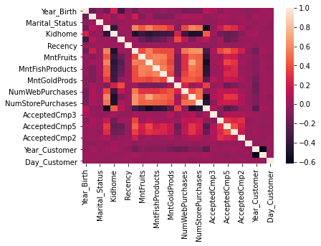
#import logistic model
x1=sm.add_constant(x)
logr_model=sm.Logit(y,x)
logr_fit=logr_model.fit()
print(logr_fit.summary())
Optimization terminated successfully.
Current function value: 0.285149
Iterations 7
Logit Regression Results
==============================================================================
Dep. Variable: Response No. Observations: 2240
Model: Logit Df Residuals: 2213
Method: MLE Df Model: 26
Date: Mon, 21 Nov 2022 Pseudo R-squ.: 0.3229
Time: 14:36:35 Log-Likelihood: -638.73
converged: True LL-Null: -943.39
Covariance Type: nonrobust LLR p-value: 6.781e-112
=======================================================================================
coef std err z P>|z| [0.025 0.975]
---------------------------------------------------------------------------------------
Year_Birth -0.0042 0.007 -0.636 0.525 -0.017 0.009
Education 0.3808 0.074 5.146 0.000 0.236 0.526
Marital_Status -0.0385 0.067 -0.572 0.567 -0.171 0.093
Income -3.489e-06 6.54e-06 -0.533 0.594 -1.63e-05 9.33e-06
Kidhome 0.0248 0.200 0.124 0.901 -0.367 0.417
Teenhome -0.8944 0.190 -4.709 0.000 -1.267 -0.522
Recency -0.0277 0.003 -9.907 0.000 -0.033 -0.022
MntWines 3.314e-05 0.000 0.095 0.924 -0.001 0.001
MntFruits 0.0025 0.002 1.127 0.260 -0.002 0.007
MntMeatProducts 0.0021 0.000 4.394 0.000 0.001 0.003
MntFishProducts 0.0003 0.002 0.147 0.883 -0.003 0.004
MntSweetProducts 0.0011 0.002 0.513 0.608 -0.003 0.005
MntGoldProds 0.0029 0.002 1.915 0.055 -6.71e-05 0.006
NumDealsPurchases 0.1120 0.045 2.512 0.012 0.025 0.199
NumWebPurchases 0.0914 0.030 3.047 0.002 0.033 0.150
NumCatalogPurchases 0.0645 0.039 1.641 0.101 -0.013 0.142
NumStorePurchases -0.1248 0.033 -3.815 0.000 -0.189 -0.061
NumWebVisitsMonth 0.2112 0.045 4.697 0.000 0.123 0.299
AcceptedCmp3 1.7678 0.216 8.202 0.000 1.345 2.190
AcceptedCmp4 1.0444 0.269 3.889 0.000 0.518 1.571
AcceptedCmp5 1.5669 0.269 5.827 0.000 1.040 2.094
AcceptedCmp1 1.0833 0.258 4.204 0.000 0.578 1.588
AcceptedCmp2 1.3486 0.514 2.622 0.009 0.341 2.356
Complain 0.4670 0.826 0.565 0.572 -1.152 2.086
Year_Customer 0.0022 0.006 0.344 0.731 -0.010 0.015
Month_Customer 0.0438 0.021 2.068 0.039 0.002 0.085
Day_Customer -0.0006 0.008 -0.066 0.947 -0.017 0.016
=======================================================================================
#dividing the train ,test group
x_train,x_test,y_train,y_test=train_test_split(x,y,train_size=0.8)
x_train
Year_Birth Education Marital_Status Income Kidhome Teenhome \
1076 1981 4 3 87171.0 0 0
507 1989 2 4 81217.0 0 0
1251 1952 2 3 67433.0 0 2
229 1986 4 5 34320.0 1 0
765 1955 2 3 48726.0 0 1
... ... ... ... ... ... ...
1148 1954 4 3 57744.0 0 1
822 1961 2 4 57091.0 0 0
1056 1974 2 3 42557.0 0 1
1265 1975 2 2 83829.0 0 0
392 1993 2 4 74293.0 0 0
Recency MntWines MntFruits MntMeatProducts ... NumWebVisitsMonth \
1076 27 1001 44 107 ... 2
507 77 493 70 324 ... 1
1251 51 615 28 259 ... 4
229 66 4 1 9 ... 8
765 90 138 3 38 ... 6
... ... ... ... ... ... ...
1148 91 350 3 39 ... 8
822 0 464 5 64 ... 5
1056 98 192 5 53 ... 8
1265 78 897 161 430 ... 1
392 66 375 152 335 ... 2
AcceptedCmp3 AcceptedCmp4 AcceptedCmp5 AcceptedCmp1 AcceptedCmp2 \
1076 1 0 1 0 0
507 0 0 0 0 0
1251 0 1 0 0 0
229 0 0 0 0 0
765 0 0 0 0 0
... ... ... ... ... ...
1148 0 0 0 0 0
822 0 0 0 0 1
1056 0 0 0 0 0
1265 1 0 1 1 0
392 0 0 0 0 0
Complain Year_Customer Month_Customer Day_Customer
1076 0 2013 5 1
507 0 2013 7 19
1251 0 2013 7 16
229 0 2014 2 16
765 0 2013 4 27
... ... ... ... ...
1148 0 2013 11 12
822 0 2014 6 15
1056 0 2012 8 29
1265 0 2013 10 8
392 0 2014 5 4
[1792 rows x 27 columns]
logreg=LogisticRegression()
loggreg_final=logreg.fit(x_train,y_train)
print(loggreg_final.score(x_train,y_train))
0.8571428571428571
D:\anaconda\lib\site-packages\sklearn\linear_model\_logistic.py:763: ConvergenceWarning: lbfgs failed to converge (status=1):
STOP: TOTAL NO. of ITERATIONS REACHED LIMIT.
Increase the number of iterations (max_iter) or scale the data as shown in:
https://scikit-learn.org/stable/modules/preprocessing.html
Please also refer to the documentation for alternative solver options:
https://scikit-learn.org/stable/modules/linear_model.html#logistic-regression
n_iter_i = _check_optimize_result(
y_pred=logreg.predict(x_test)
#confusion matrix for the logistic model prediction
cm=confusion_matrix(y_test, y_pred)
print(cm)
[[373 3]
[ 63 9]]
print(classification_report(y_test, y_pred))
precision recall f1-score support
0 0.86 0.99 0.92 376
1 0.75 0.12 0.21 72
accuracy 0.85 448
macro avg 0.80 0.56 0.57 448
weighted avg 0.84 0.85 0.81 448
#SVM model
svc_model=svm.SVC(kernel='linear')
svc_final=svc_model.fit(x_train,y_train)
print(svc_final.score(x_train,y_train))
0.8560267857142857
y_pred1=svc_model.predict(x_test)
print(classification_report(y_test,y_pred1))
precision recall f1-score support
0 0.85 0.97 0.91 376
1 0.47 0.12 0.20 72
accuracy 0.84 448
macro avg 0.66 0.55 0.55 448
weighted avg 0.79 0.84 0.79 448
#confusion matrix for the svm model prediction
cm1=confusion_matrix(y_test, y_pred1)
print(cm1)
[[366 10]
[ 63 9]]
#getting the weights of features
print(svc_model.coef_)
[[ 0.48003175 19.81709214 1.38982251 -0.10117447 25.17336337
-21.48215447 -24.18196323 3.77780032 1.91152084 5.48294883
-6.54978664 3.77556507 2.03882585 -4.99606183 11.90522659
90.12795447 -100.37415707 47.88589587 40.36333589 17.63103316
27.63103316 36.63103316 12. 1. -36.48818471
-18.46622262 -0.29859321]]
#here we see that accuracy using the two models is 84% and 85%

THANK YOU

